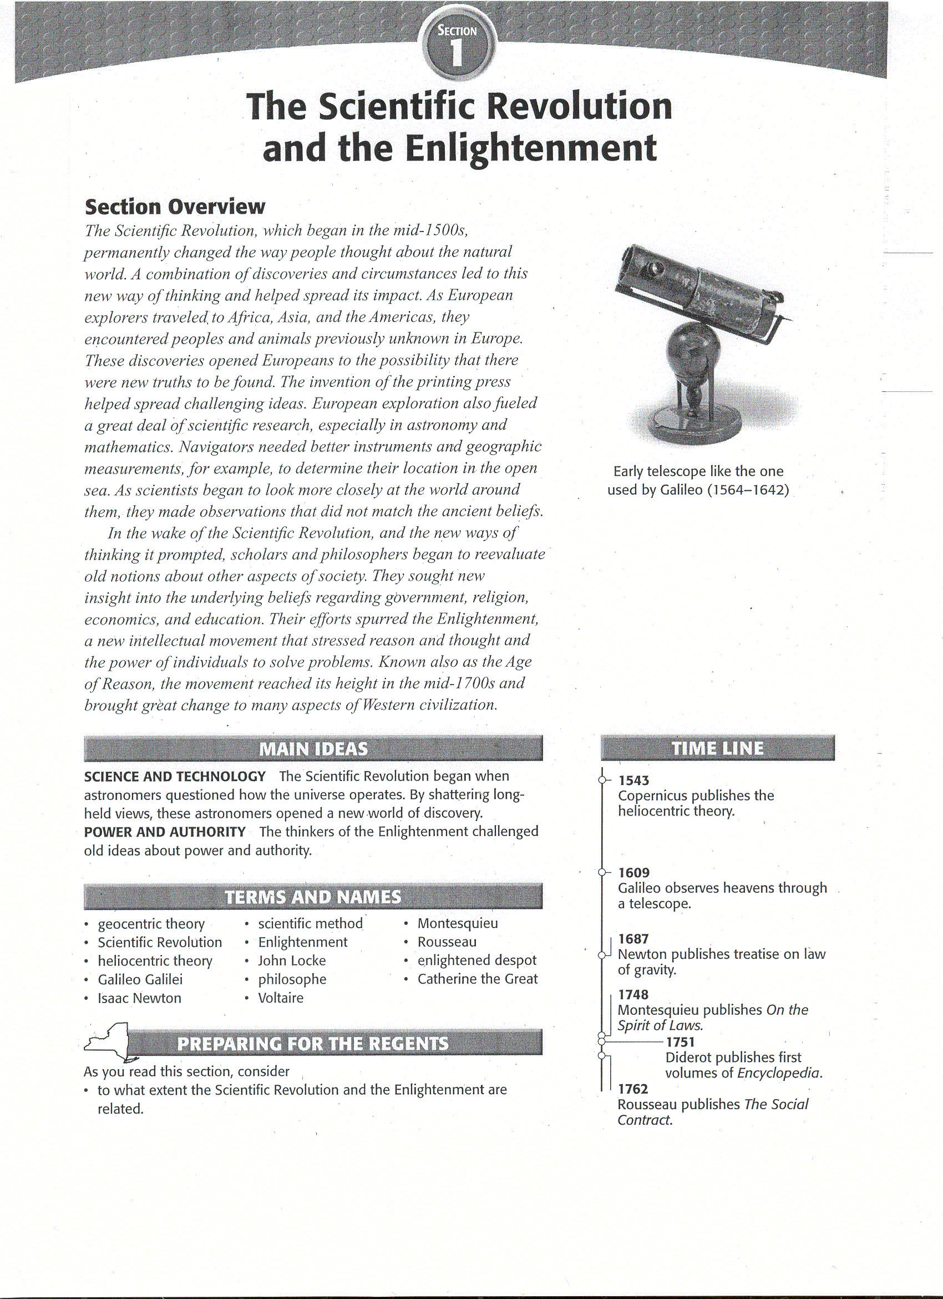

The Scientific Revolution

During the Middle Ages, most scholars believed that the moon, the sun, and the planets all moved in perfectly circular paths around an immovable earth. This earth-centered view of the universe was called the geocentric theory. The idea came from Aristotle, the Greek philosopher of the fourth century B.C. The Greek astronomer Ptolemy (TOL*a*mee) expanded the theory in the second century A.D. In addition, Christianity taught that God had deliberately placed the earth at the center of the universe.
Beginning in the mid -1500s, a few scholars published works that challenged the ideas of the ancient thinkers and the church. As these scholars replaced old assumptions' with new theories, they launched a change in European thought that historians call the Scientific Revolution. The Scientific Revolution was a new way of thinking about the natural world. That way was based upon careful observation and a willingness to question accepted beliefs.
Nicolaus Copernicus An early challenge to accepted scientific thinking came in the field of astronomy. The fact that geocentric theory did not accurately explain the movements of the sun, moon, and planets troubled a Polish cleric and astronomer named Nicolaus Copernicus (koh*PUR*nuh*kuhs). In the early l500s, Copernicus became interested in an old Greek idea that the sun stood at the center of the universe. After studying planetary movements for more than 25 years, Copernicus reasoned that indeed, the stars, the earth, and the other planets revolved around the Sun. In 1543, Copernicus published his findings in On the Revolutions of Heavenly Bodies.
Copernicus's heliocentric, or sun-centered, theory did not completely explain why the planets orbited the way they did. Other scientists would build on the foundation laid by Copernicus. In the early l600s, for instance, Johannes Kepler concluded that certain mathematical laws govern planetary motion. One of these laws showed that the planets revolve around the sun in elliptical orbits instead of circles, as previously thought.
Galileo Galilei An Italian scientist named Galileo Galilei built on the new theories about astronomy. As a young man Galileo learned that a Dutch lens maker had built an instrument that could enlarge far-off objects. Galileo built his own telescope and used it to study the heavens in 1609. Then, in 1610, he published a small book called Starry Messenger, which described his astonishing observations. Galileo announced that Jupiter had four moons and that the sun had dark spots. He also noted that the earth's moon had a rough, uneven surface. This shattered Aristotle’s theory that the moon and stars were made of a pure, perfect substance. Galileo's observations, as well as his laws of motion, also clearly supported the theories of Copernicus.
Galileo's findings frightened both Catholic and Protestant leaders because they went against church teaching and authority. If people believed the church could be wrong about this, they could question other church teachings as well. In 1616, the Catholic Church warned Galileo not to defend the ideas of Copernicus.
Although Galileo remained publicly silent, he continued his studies. Then, in 1632, he published Dialogue Concerning the Two Chief World Systems. This book presented the ideas of both Copernicus and Ptolemy, but it clearly showed that Galileo supported the Copernican theory. Galileo was ordered to stand trial before the Inquisition in 1633. Under the threat of torture, he knelt before Catholic leaders and read aloud a signed confession. In it, he agreed that the ideas of Copernicus were false. Galileo spent the remainder of his life under house arrest.
Isaac Newton The English scientist Isaac Newton helped to bring together the breakthroughs of Copernicus, Kepler, and Galileo under a single theory of motion. Newton's great discovery was that the same force ruled motion of the planets and all matter of earth and in space. The key idea that linked motion in the heavens with motion on the earth was the law of universal gravitation. According to this law, every object in the universe attracts every other object. The degree of attraction depends on the mass of the objects and the distance between them. Newton published his ideas in The Mathematical Principles of Natural Philosophy (1687), one of the most important scientific books ever written. The universe he described was like a giant clock. Its parts all worked together perfectly in ways that could be expressed mathematically. Newton believed that God was the creator of this orderly universe, the clockmaker who had set everything in motion.
The Scientific Method The revolution in scientific thinking eventually developed into a new approach to science called the scientific method. This method is a logical procedure for gathering and testing ideas. It begins with a problem or question arising from an observation. Scientists next form a hypothesis, or unproved assumptions. The hypothesis is then tested in an experiment or one basis of data. In the final step, scientists analyze and interpret their data to reach a new conclusion. That conclusion either confirms or disproves the hypothesis.
The work of 15th-century thinkers Francis Bacon of England and Rene Descartes (day*KAHRT) of France helped to advance the scientific method. Bacon urged scientists to experiment and then draw conclusions. This approach is called, empiricism, or the experimental method. Descartes developed analytical geometry, which linked algebra and geometry. Rather than using experimentation as Bacon did, Descartes relied on mathematics and logic. He believed that everything should be doubted until proved by reason. The only thing he knew for certain was that he existed-because, as he wrote, "I think, therefore I am." From this starting point, he followed a train of strict reasoning to arrive at other basic truths.

The Enlightenment
In the wake of the Scientific Revolution, scholars and philosophers began to reevaluate old notions about other aspects of society. They sought new insight into the underlying beliefs regarding government, religion, economics, and education. Their efforts spurred the Enlightenment, a new intellectual movement that stressed reason and thought and the power of individuals to solve problems. Known also as the Age of Reason, the movement reached its height in the mid - l700s and brought great change to many aspects of Western civilization.
The Enlightenment started from some key ideas put forth by two English political thinkers of the l600s, Thomas Hobbes (pessimist) - whom you have already read about - and John Locke (optimist). Both men experienced the political turmoil of England early in that century. However, they came to very different conclusions. Thomas Hobbes supported an absolute monarchy. The horrors of the English Civil War convinced him that all humans were naturally selfish and wicked. The only answer was for people to enter a social contract in which they handed over their rights to a strong ruler with absolute power in exchange for law and order. The philosopher John Locke held a different, more positive, view of human nature. He favored self-government. According to Locke, all people are born free and equal, with three natural rights - life, liberty, and property. The purpose of government, said Locke, is to protect these rights. If a government fails to do so, citizens have a right to overthrow it.
Enlightenment Writers The Enlightenment reached its height in France in the mid-1700s. Paris became the meeting place for people who wanted to discuss politics and ideas. The social critics of this period in France were known as philosophes (FIHL*uh*SAHFs), the French word for philosophers. The philosophes believed that people could apply reason to all aspects of life, just as Isaac Newton had applied reason to science.
Probably the most brilliant and influential of the philosophes was François Marie Arouet. Using the pen name Voltaire, he published more than 70 books of political essays, philosophy, and drama. Although he made powerful enemies, Voltaire never stopped fighting for tolerance, reason, freedom of religious belief, and freedom of speech.
Baron de Montesquieu (MAHN*tuh*skyoo) was another influential French philosophe. Montesquieu believed that Britain was the most politically balanced and best-governed country of his own day. The British king and his ministers held executive power. They carried out the laws of the state. The members of Parliament held legislative power. They made the laws. The judges of the English courts held judicial power. They interpreted the laws to see how each applied to a specific case. Montesquieu called this division of power among different branches separation of powers. Montesquieu oversimplified the British system. It did not actually separate powers this way. His idea, however, became a part of his most famous book, On the Spirit of Laws (1748). In his book, Montesquieu proposed that separation of powers would keep any individual or group from gaining total control of the government. "Power," he wrote, "should be a check to power." This idea later would be called checks and balances.
A third great philosophe was Jean Jacques Rousseau (roo*SOH). Rousseau believed that the only good government was one that was freely formed by the people and guided by the "general will" of society - a direct democracy. As he explained in his book, The Social Contract (1762), under such a government, people agree to give up some of their freedom in favor of the common good. Rousseau's view of the social contract differed greatly from that of Hobbes. For Hobbes, the social contract was an agreement between a society and its government. For Rousseau, it was an agreement among free individuals to create a society and a government.
Another leading philosophe, Denis Diderot (DEE*du*roh), created a large set of books to which many leading scholars of Europe contributed articles and essays. He called it Encyclopedia and began publishing the first volumes in 1751. The Enlightenment views expressed in the articles soon angered both the French government and the Catholic Church. Their censors banned the work. Nonetheless, Diderot continued publishing his Encyclopedia.
The Impact of the Enlightenment Enlightenment writers challenged long-held ideas about society. They examined such principles as the divine right of monarchs, the union of church and state, and the existence of unequal social classes. They held these beliefs up to the light of reason and found them in need of reform. The theories they popularized eventually inspired the American and French revolutions and other revolutionary movements in the 1800s. Enlightenment thinking produced three other long-term effects that helped shape Western civilization. The first effect was a belief in progress. Galileo, Newton, and others had discovered the key for unlocking the mysteries of nature in the 1500s and 1600s. With the door thus opened, the growth of scientific knowledge seemed to quicken in the 1700s. A second outcome was the rise of a more secular, or non-religious, outlook. Before the Scientific Revolution, people accepted the mysteries of the universe as the workings of God. One by one, scientists discovered that these mysteries could be explained mathematically. Faith in science and in progress produced a third outcome, the rise of individualism. The philosophes encouraged people to use their own ability to reason in order to judge what was right or wrong. They also emphasized the importance of the individual in society. Government, they argued, was formed by individuals to promote their welfare.
Enlightenment and the Monarchy Many philosophes, including Voltaire, believed that the best form of government was a monarchy in which the ruler respected the people's rights. The philosophes tried to convince monarchs to rule justly. Some monarchs embraced the new ideas and made reforms that reflected the Enlightenment spirit. They became known as enlightened despots. Despot means "absolute ruler." The enlightened despots supported the philosophes' ideas. But they also had no intention of giving up any power. The changes they made were motivated by two desires: they wanted to make their countries stronger and their own rule more effective. The foremost of Europe's enlightened despots were Frederick II of Prussia, Holy Roman Emperor Joseph II of Austria, and Catherine II of Russia.
Frederick II, known as Frederick the Great, granted many religious freedoms, reduced censorship, improved education, reformed the justice system, and abolished the use of torture. Frederick's most important contribution, however, was his attitude toward being king. He called himself "the first servant of the state." Joseph II, the son and successor of Maria Theresa, introduced legal reforms, freedom of the press, and freedom of worship. In his most radical reform, he abolished serfdom. The abolition of serfdom, like many of Joseph's reforms, was undone after his death. Catherine II, known as Catherine the Great, was the ruler most admired by the philosophes. She ruled with absolute authority but also sought to reform Russia. Few of her proposed reforms were carried out, however.

