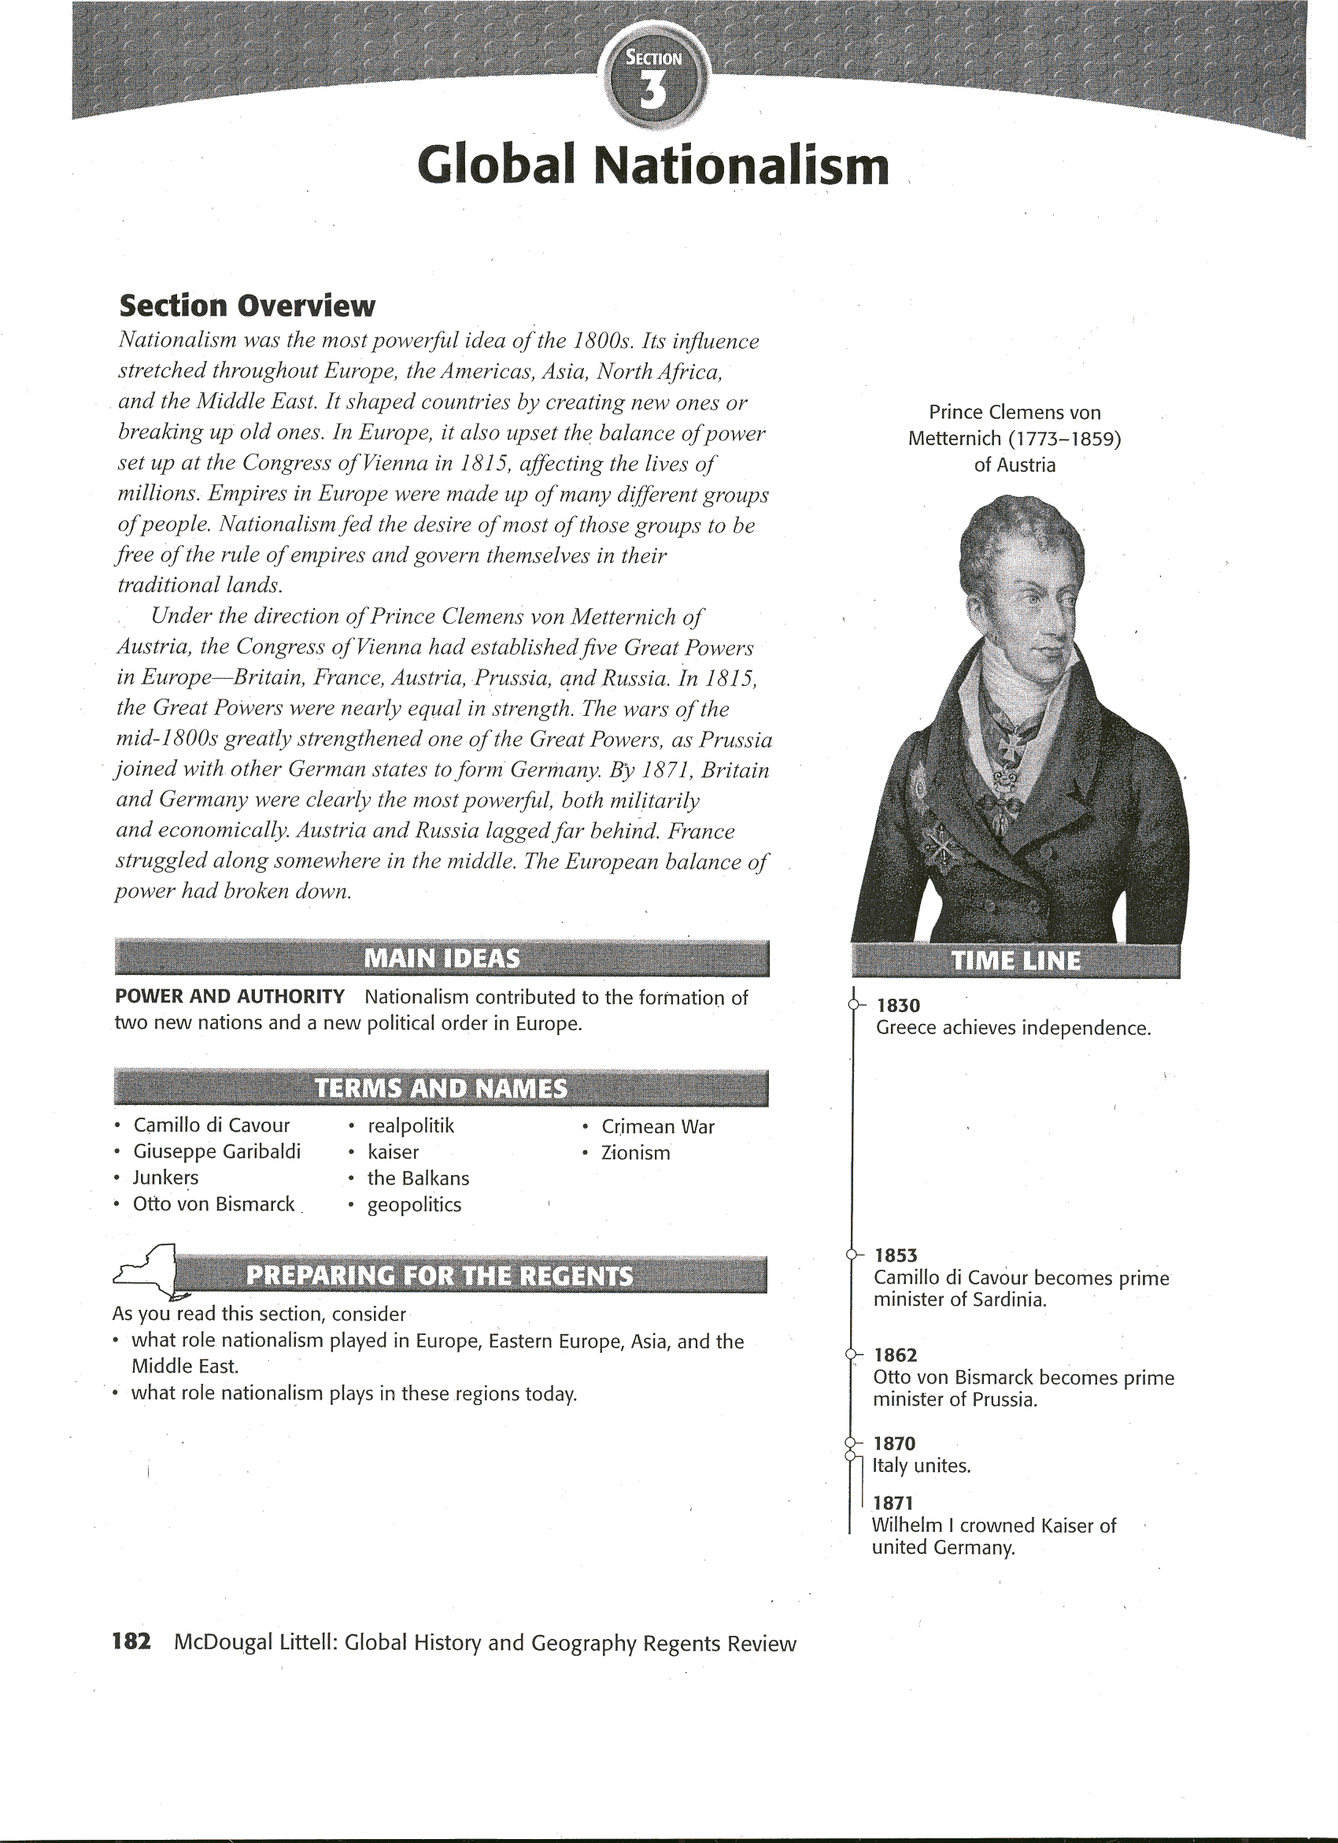

**Human and Physical Geography**

Nationalism - the belief that people should be loyal to their nation-was not widespread until the l800s. The rise of modem nationalism is tied to the spread of democratic ideas and the growth of an educated middle class. People wanted to decide how they were governed, instead of having monarchs impose government on them.

Most of the people who believed in nationalism were either liberals or radicals. In most cases, the liberal middle class - teachers, lawyers, and businesspeople - led the struggle for constitutional government and the formation of nation-states. (As you learned in Unit 3, Section 5, a nation becomes a nation-state when it has its own independent government.) In Europe in 1815, only France, England, and Spain could be called nation-states. But that would soon change as nationalism fueled efforts to build nation-states. In Germany, for example, liberals wanted to gather the many different German states into a single nation-state. Other liberals in large empires, such as the Hungarians in the Austrian Empire, wanted to split away and establish self-rule.

Nationalists were not loyal to kings, but to people - to those who shared common bonds. They believed that people of a single nationality, or ancestry, should unite under a single government. In contrast, people who wanted to restore the old order from before the French Revolution saw nationalism as a force for disunity. Gradually, however, authoritarian rulers began to 8see that nationalism could also unify masses of people. They soon began to use nationalist feelings for their own purposes. They built nation-states in areas where they remained firmly in control.

# A Force for Unity and Self-Determination

While nationalism destroyed empires, it also built nations. Italy and Germany were two European nation-states to achieve unity in the mid-1800s.

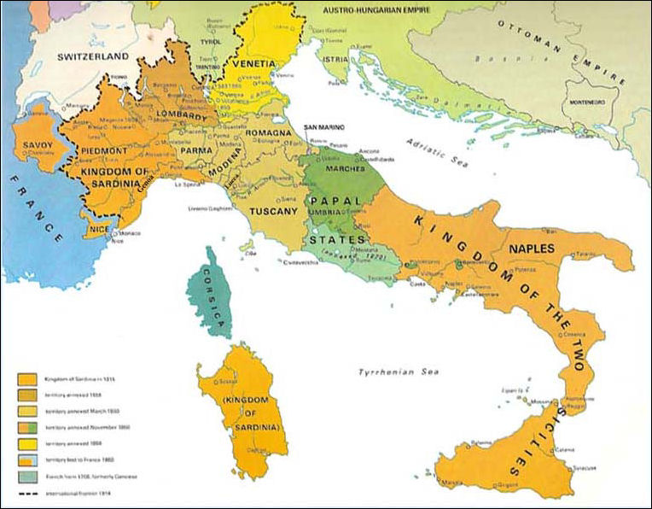

**Italy** Between 1815 and 1848, fewer and fewer Italians were content to live under foreign rulers. Italian nationalists looked for leadership from the kingdom of Piedmont-Sardinia, the largest and most powerful of the Italian states. The kingdom had adopted a liberal constitution in 1848. So, to the liberal Italian middle classes, unification under Piedmont-Sardinia seemed a good plan.

Sardinia's king, Victor Emmanuel II, named Count **Camillo di Cavour** (kuh*VOOR) as his prime minister in 1853. Cavour set about gaining control of northern Italy for Sardinia. He realized that the greatest roadblock to annexing northern Italy was Austria. In 1858, the French agreed to help drive Austria out of the northern Italian provinces. Cavour then provoked a war with the Austrians in which Sardinia succeeded in taking all of northern Italy, except Venetia.

As Cavour was uniting northern Italy, he secretly started helping nationalist rebels in southern Italy. In May 1860, a small army of Italian nationalists led by **Giuseppe Garibaldi** (gar*uh*BAWL*dee) captured Sicily. From Sicily, Garibaldi and his rebel forces crossed to the Italian mainland and marched north. Eventually, Garibaldi agreed to unite the southern areas he had conquered with the kingdom of Piedmont-Sardinia and let King Victor Emmanuel II rule.

In 1866, the Austrian province of Venetia, which included the city of Venice, became part of Italy. Then, in 1870, Italian forces took over the last part of a territory known as the Papal States. With this victory, the city of Rome came under Italian control. Soon after, Rome became the capital of the united kingdom of Italy. The pope, however, would continue to govern a section of Rome known as Vatican City.

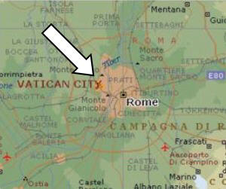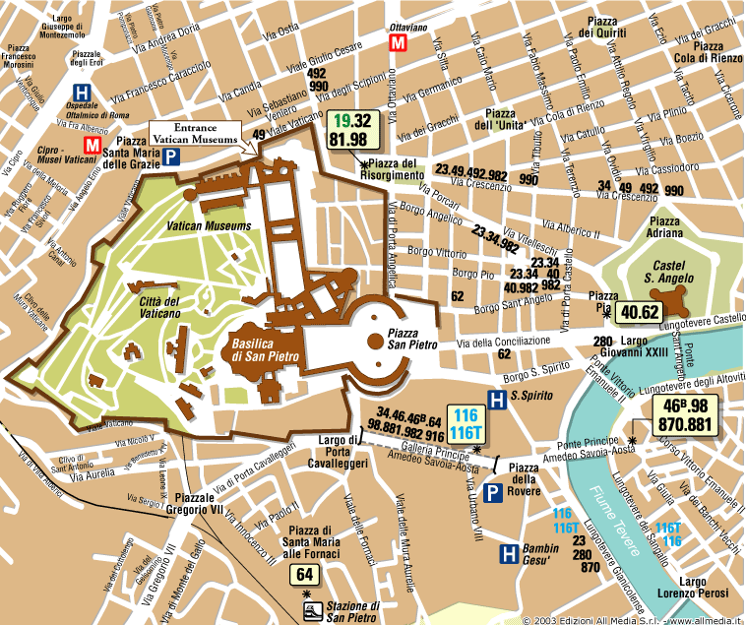

**Germany** Like Italy, Germany also achieved national unity in the mid-1800s. Beginning in 1815, 39 German states formed a loose grouping called the German Confederation. 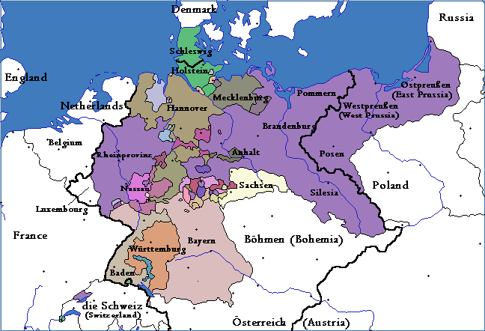

The Austrian Empire dominated the confederation. However, Prussia was ready to unify all the German states.

Prussia enjoyed several advantages that would eventually help it forge a strong German state. First of all, unlike the Austro-Hungarian Empire, Prussia had a mainly German population. As a result, nationalism actually unified Prussia. In contrast, ethnic groups in Austria-Hungary tore the empire apart. Moreover, Prussia's army was by far the most powerful in central Europe: In 1848, Berlin rioters forced a constitutional convention to write up a liberal constitution for the kingdom, paving the way for unification.

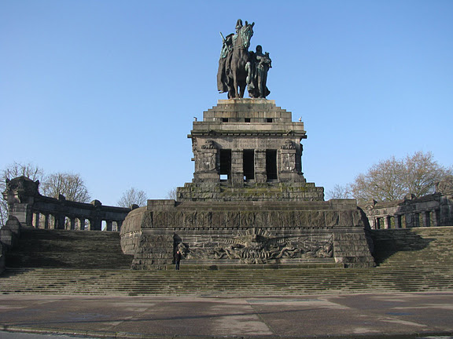

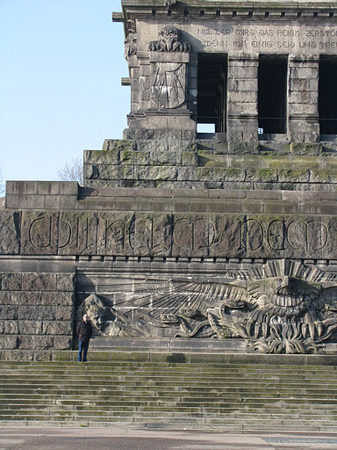

In 1861, Wilhelm I succeeded Frederick William to the throne. The liberal parliament refused him money for reforms that would double the strength of the army. Wilhelm saw the parliament's refusal as a major challenge to his authority. He was supported in his view by the **Junkers** (YUNG*kuhrz), strongly conservative members of Prussia's wealthy landowning class. In 1862, Wilhelm chose a conservative Junker named **Otto von Bismarck** as his prime minister. Bismarck was a master of what came to be known as **realpolitik**. This German term means "the politics of reality." The term is used to describe tough power politics with no room for idealism.

In 1864, Bismarck took the first step toward molding an empire. Prussia and Austria formed an alliance and went to war against Denmark to win two border provinces, Schleswig and Holstein. A quick victory increased national pride among Prussians. It also won new respect from other Germans and lent support for Prussia as head of a unified Germany. After the victory, Prussia governed Schleswig, while Austria controlled Holstein.

Bismarck purposely stirred up border conflicts with Austria over Schleswig and Holstein, provoking Austria to declare war in 1866. The Seven Weeks' War was a humiliating defeat for Austria. The Austrians lost Venetia, which was given to Italy, and had to accept Prussian annexation of more German territory. Prussia took control of northern Germany. For the first time, the eastern and western parts of the Prussian kingdom were joined. In 1867, the remaining states of the north joined the North German Confederation, which Prussia dominated.

By 1867, a few southern German states remained independent of Prussian control. The majority of southern Germans were Catholics, and many resisted domination by a Protestant Prussia. However, Bismarck felt he could win the support of southerners if they faced a threat from outside. He reasoned that a war with France would rally the south. Bismarck was an expert at manufacturing "incidents" to gain his ends. The resulting conflict - the Franco-Prussian War - was the final stage in German unification. People in southern Germany finally accepted Prussian leadership. On January 18, 1871, King Wilhelm I of Prussia was crowned **kaiser** (KY*zuhr), or emperor. Germans called their empire the Second Reich. (The Holy Roman Empire was the first.) During his time as prime minister Bismarck used the motto “blood and iron” to express his policies.

[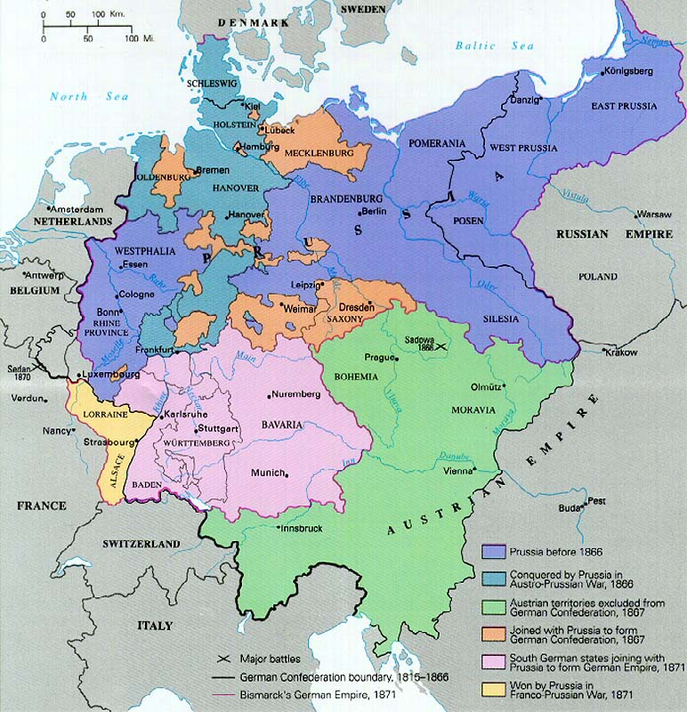](http://www.mbc.edu/faculty/gbowen/MapGerman19thCenturyUnification.jpg)

**India** Nationalist movements were not limited to Europe. Nationalist feelings started to surface in India in the 1800s. At that time, India was part of the British colonial system. Indians hated this system, which made them second-class citizens in their own country. They were barred from top posts in the Indian Civil Service. Those who managed to get middle-level jobs were paid less than Europeans. A British engineer on the East India Railway, for example, made nearly 20 times as much money as an Indian engineer. This growing nationalism led to the founding of two nationalist groups, the Indian National Congress in 1885 and the Muslim League in 1906. At first, such groups concentrated on specific concerns for Indians. By the early 1900s, however, they were calling for self-government.

**Turkey and the Young Turks** By the early 1900s, the Ottoman Empire was in rapid decline. Fueled by nationalist feelings, many subject groups had succeeded in breaking away from their Turkish rulers (see below). Nationalist feelings however, were not limited to the Ottomans' subject peoples. There was also a growing nationalist movement among Ottoman Turks. This movement came to a head in 1908, when a group known as the Young Turks staged a series of revolts that led the sultan to restore a liberal constitution that had been granted in 1876 but later withdrawn. The Young Turks helped push through many reforms. The sultan lost much of his power, parliamentary elections were instituted, and the secret police and censorship were dismantled. The Young Turks also supported improvements in women's rights. However, when conservatives staged a counter-revolution, the Young Turks seized power and ruled as virtual dictators.

# A Force for Conflict

Nationalism often served as a source of conflict, as groups struggled to break free from the empires that had absorbed them. This was particularly true for groups under Ottoman control.

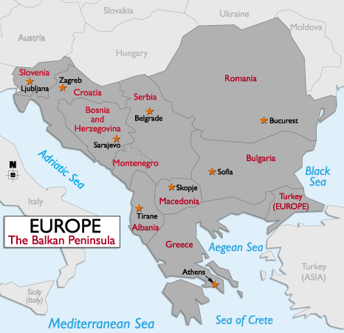

**The Balkans** In the early 1800s, the Ottoman Empire controlled most of the **Balkans.** This mountainous peninsula in the southeastern comer of Europe includes all or part of present-day Greece, Albania, Bulgaria, Romania, Turkey, and the former Yugoslavia. In 1830, Greece gained its independence, and Serbia gained self-rule. By early 1914, other groups had succeeded in breaking away from Turkish rule. These peoples had formed new nations, including Bulgaria, Montenegro, and Romania. Nationalism was a powerful force in these countries. Each group longed to extend its borders. Serbia, for example, had a large Slavic population. It hoped to absorb all the Slavs on the Balkan Peninsula. Russia, itself a mostly Slavic nation, supported Serbian nationalism. However, Serbia's powerful northern neighbor, Austria-Hungary, opposed such an effort. Austria feared that efforts to create a Slavic state would stir rebellion among its Slavic population.

In 1908, Austria annexed, or took over, Bosnia and Herzegovina. These were two Balkan areas with large Slavic populations. Serbian leaders, who had sought to rule these provinces, were outraged. In the years that followed, tensions between Serbia and Austria steadily rose. The Serbs continually vowed to take Bosnia and Herzegovina away from Austria. In response, Austria-Hungary vowed to crush any Serbian effort to undermine its authority in the Balkans.

**The Ottoman Empire** Nationalists efforts often caused tensions in the empire. For example, in response to nationalism in Armenia, the Ottomans massacred and deported Armenians from 1894 to 1896 and again in 1915. The Ottomans also faced problems with European powers. As the empire weakened, the Europeans began to look for ways to take control of Ottoman lands. **Geopolitics,** an interest in or taking of land for its strategic location or products, played an important role in the fate of the Ottoman Empire. World powers were attracted to its strategic location. The Ottomans controlled access to the Mediterranean and the Atlantic sea trade.

The Ottomans became a pawn in the game of European geopolitics. In 1853, for instance, the Russians started the **Crimean War** with the Ottomans in an effort to secure a warm-weather port on the Black Sea. Fearful that Russia would gain control of additional. Ottoman lands, Britain and France entered the War on the side of the Ottoman Empire. The combined forces defeated Russia. However, the war revealed the Ottoman Empire's military weakness. Despite the help of Britain and France, the Ottoman Empire continued to lose lands in Europe and Africa. By the beginning of World War I, the Ottoman Empire was reduced in size and in deep decline.

## Zionism

Many Jewish people also embraced nationalism. After being forced out of Palestine during the second century, the Jewish people were not able to establish their own state and lived in different countries throughout the world. The global dispersal of the Jews is known as the Diaspora. For many Jews, the long history of exile and persecution convinced them to work for a homeland in Palestine. In the l890s, a movement known as **Zionism** developed to pursue this goal. Its leader was Theodor Herzl (HEHRT*suhl), a writer in Vienna. It took many years, however, before the state of Israel was established.

