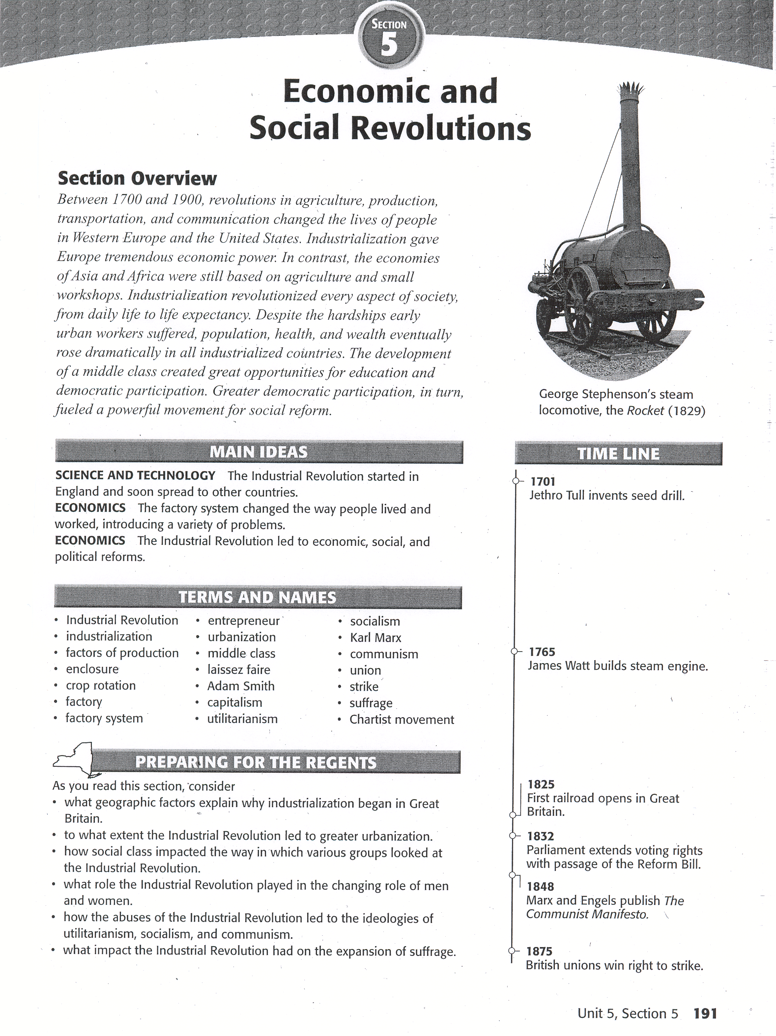

### Human and Physical Geography

The **Industrial Revolution** refers to the greatly increased output of machine made goods that began in England in the middle l700s. There are several reasons why the Industrial Revolution began in England. In addition to political stability and a large population of workers, England had the extensive natural resources required for **industrialization -** the process of developing machine production of goods. These natural resources included 1) water power and coal to fuel the new machines; 2) iron ore to construct machines, tools, and buildings; 3) rivers for inland transportation; and 4) harbors from which merchant ships set sail. Britain's highly developed banking system also contributed to industrialization by providing bank loans that, allowed people to invest in new machinery and expand their operations. Growing overseas trade, economic prosperity, and a climate of progress led to the increased demand for goods. Other countries had some of these advantages. But Britain had all the **factors of production-** the land, labor, and capital (or wealth) needed to produce goods and services- that the Industrial Revolution required. It did not take long, however, for the Industrial Revolution to spread to Continental Europe and North America.

# Agrarian Revolution (a.k.a. 2nd Agricultural Revolution)

A revolution in farming also helped pave the way for the Industrial Revolution. In 1700, wealthy landowners began buying up much of the land that village farmers had once worked. They combined the land into larger fields, which were called **enclosures** because they were enclosed by fences or hedges. The enclosure movement had two important results. First, landowners tried new agricultural methods developed by scientific farmers. Second, large landowners forced small farmers to become tenant farmers or to give up farming and move to the cities.

Farmers took advantage of Jethro Tull's seed drill, which allowed them to sow seeds in well-spaced rows at specific depths. A larger share of the seeds took root, boosting crop yields.

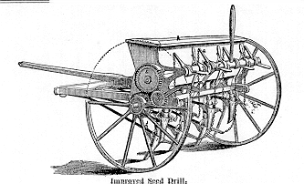

They also adopted a new process of **crop rotation**. One year, for example, it farmer might plant a field with wheat, which exhausted soil nutrients. The next year he planted a root crop, such as turnips, to restore nutrients. This might be followed in turn by barley and then clover. 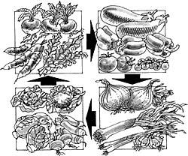

Livestock breeders also improved their methods, which resulted in increased output. As food supplies increased and living conditions improved, England's population mushroomed. An increasing population boosted the demand for food and goods such as cloth. As farmers lost their land to large enclosed farms, many became factory workers.

### The British Industrial Revolution

In an explosion of creativity, inventions now revolutionized industry. Britain's textile industry clothed the world in wool, linen, and cotton. This industry was the first to be transformed. Cloth merchants boosted their profits by speeding up the process by which spinners and weavers made cloth.

**Changes in the Textile Industry** By 1800, several major inventions had modernized the cotton industry. In 1733, John Kay invented the flying shuttle, a boat-shaped piece of wood to which yarn was attached. The shuttle, which sped back and forth on wheels, doubled the work a weaver could do in a day. Around 1764, James Hargreaves invented a faster spinning wheel - the spinning jenny (named after his daughter)-which allowed one spinner to work eight threads at a time. At first, textile workers operated the flying shuttle operated the spinning jenny by hand. Then, in 1769, Richard Arkwright invented the water frame, which used the waterpower from rapid streams to drive spinning wheels. In 1779, Samuel Crompton combined features of the spinning jenny and the water frame to produce the spinning mule. The spinning mule made thread that was stronger, finer, and more consistent than earlier spinning machines. Run by waterpower, Edmund Cartwright's power loom sped up weaving after its invention in 1787.

**Growth of the Factory System** The new spinning machinery was bulky and expensive. Wealthy textile merchants set up the machines in large buildings called **factories.** This marked the shift from cottage industries, in which spinning and weaving were done in people's homes, to the **factory system**, where the manufacturing of goods was concentrated in a central location.

By the late l700s, steam-driven machinery powered English factories. The development of the steam engine stemmed from the search for a cheap, convenient source of power. As early as 1705, coal miners were using steam-powered pumps to remove water from deep mine shafts. But pumps gobbled great quantities of fuel, making them expensive to run. In 1765, James Watt figured out a way to make the steam engine work faster and more efficiently while burning less fuel.

**Improvements in Transportation** Transportation also underwent improvements in the 1800s. An American inventor named Robert Fulton used a steam engine to build a steamboat called the *Clermont,* which made its first successful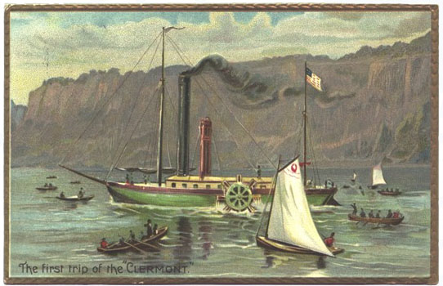trip in 1807. In England, water transportation improved with the creation of a network of canals, or human-made waterways, that slashed the cost of transporting both raw materials and finished goods. British roads also improved. Private investors formed companies that built roads and then operated them for profit. People called the new roads turnpikes because travelers had to stop at tollgates (turnstiles or turnpikes) to pay tolls before traveling farther.

Even more important was the development of a steam engine on wheels - the railroad locomotive. In 1821, George Stephenson began work on the world's first railroad line. It was to run 27 miles from the Yorkshire coalfields to the port of Stockton on the North Sea. In 1825, the railroad opened. It used four locomotives that Stephenson had designed and built. The invention and perfection ofthe locomotive had at least four major effects. First, railroads spurred industrial growth by giving manufacturers a cheap way to transport materials and finished products. Second, the railroad boom created hundreds of thousands of new jobs for both railroad workers and the miners who provided iron for the tracks and coal for the steam engines. Third, the railroads boosted England's agricultural and fishing industries, which could transport their products to distant cities. Finally, by making travel easier, railroads encouraged country people to take distant city jobs and lured city dwellers to resorts in the countryside.

### Consequences of Industrialization

The Industrial Revolution affected every part of life in Great Britain, but proved to be a mixed blessing. Eventually, industrialization led to a better quality of lifefor most people. But the change to machine production initially caused human suffering. Rapid industrialization brought plentiful jobs, but it also caused unhealthy working conditions, air and water pollution, the ills of child labor, and rising class tensions.

**Urbanization** For centuries, most Europeans had lived in rural areas. After 1800, the balance shifted toward cities. This shift was caused by the growth of the factory system. Factories developed in clusters because **entrepreneurs** (AHN*truh*pruh*NURS)--people who organize, manage, and take on the risks of a business-built them near sources of energy, such as water and coal. Between 1800 and 1850, the number of European cities boasting more than 100,000 inhabitants rose from 22 to 47. Most of Europe's urban areas at least doubled in population; some even quadrupled. This period was one of **urbanization-** city buildingand the movement of people to cities.

Because England's cities grew rapidly, they had no development plans, sanitary codes, or building codes. Moreover, they lacked adequate housing, education, and police protection for the people who poured in from the countryside to seek jobs. Workers lived in dark, dirty shelters, with whole families crowding into one bedroom. Sickness was widespread. Epidemics of the deadly disease cholera regularly swept through the slums of Great Britain's industrial cities. In 1842, a British government study showed an average life span to be 17 years for working-class people in one large city, compared with 38 years in a nearby rural area. But not everyone in urban areas lived miserably. Well-to-do merchants and factory owners often built luxurious homes in the suburbs.

**Working Conditions** To increase production, factory owners wanted to keep their machines running as many hours as possible. As a result, the average worker spent 14 hours a day at the job, 6 days a week. Workers faced many dangers. Factories were seldom well lit or clean. Machines injured workers. And there was no government program to provide aid in case of injury. The most dangerous conditions of all were underground in coalmines. Frequent accidents, damp conditions, and the constant breathing of coal dust made the average miller's life span ten years shorter than that of other workers. Many women and children were employed in the mining industry because they were the cheapest source of labor.

**Social Classes and Changing Roles** Though poverty gripped Britain's working classes, the Industrial Revolution created enormous wealth in the nation. Most of this new money belonged to factory owners, shippers, and merchants. These people were part of a growing **middle class,** a social class made up of skilled workers, professionals, businesspeople, and wealthy farmers.

The new middle class transformed the social structure of Great Britain. In the past, landowners and aristocrats had occupied the top position in British society. With most of the wealth, they wielded the social and political power. Now some factory owners, merchants, and bankers grew wealthier than the landowners and aristocrats. Yet important social distinctions divided the two wealthy classes. Landowners looked down on those who had made their fortunes in the "vulgar" business world. Not until late in the 1800s were rich entrepreneurs considered the social equals of the lords of the countryside.

Gradually, a larger middle class-neither rich nor poor-emerged. The upper middle class consisted of government employees, doctors, lawyers, and managers of factories, mines, and shops. The lower middle class included factory overseers and such skilled workers as toolmakers, mechanical drafters, and printers. These people enjoyed a comfortable standard of living.

During the years 1800 to 1850, however, laborers, or the working class, saw little improvement in their living and working conditions. They watched their livelihoods disappear as machines replaced them. In frustration, some smashed the machines they thought were putting them out of work.

**Effects of the Industrial Revolution** Despite the problems that followed industrialization, the Industrial Revolution had a number of positive effects. It created jobs for workers. It contributed to the wealth of the nation. It fostered technological progress and invention. It greatly increased the production of goods and raised the standard of living. Perhaps most important, it provided the hope of improvement in people's lives.

The Industrial Revolution produced a number of other benefits as well. These included healthier diets, better housing, and cheaper, mass-produced clothing. Because the Industrial Revolution created a demand for engineers as well as clerical and professional workers, it expanded educational opportunities. The middle and upper classes prospered immediately from the Industrial Revolution. For the workers it took longer, but their lives gradually improved during the l800s. Laborers eventually won higher wages, shorter hours, and better working conditions after they joined together to form labor unions.

## Responses to Industrialization

In industrialized countries in the 19th century, the Industrial Revolution opened a wide gap between the rich and the poor. This gap inspired many writers of the era. The English realist novelist Charles Dickens created unforgettable characters and scenes of London's working poor. Many of the scenes showed the despair of London's poor. In his book ***Little Dotrit****,* Dickens described the life of a working-class person as sheer monotony set in a gloomy neighborhood. The novels of the French writer Emile Zola exposed the miseries of French workers in small shops, factories, and coalmines. His revelations shocked readers and spurred reforms of labor laws and working conditions in France.

Business leaders believed that governments should stay out of business and economic affairs. Reformers, however, felt that governments needed to play an active role to improve conditions for the poor. Workers also demanded more rights and protection. They formed labor unions to increase their influence.

**Philosophers of Industrialization** The term **laissez faire** (LEHS*eay*FAIR) - refers to the economic policy of letting owners of industry and business set working conditions without interference. This policy favors a free market unregulated by the government. The term is French for "let do," and by extension, "let people do as they please." Laissez-faire economics stemmed from French economic philosophers of the Enlightenment. They criticized the idea that nations grow wealthy by placing heavy tariffs on foreign goods. They believed that if government allowed free trade-the flow of commerce in the world market without government regulation - the economy would prosper.

**Adam Smith,** (the father of capitalism)a professor at the University of Glasgow, Scotland, defended the idea of a free economy, or free markets, in his 1776 book ***The Wealth of Nations****.* According to Smith, economic liberty guaranteed economic progress. As a result, government should not interfere. Smith's arguments rested on what he called the three natural laws of economics: 1) the law of self-interest - people work for their own good; 2) the law of competition - competition forces people to make a better product; and 3) the law of supply and demand - enough goods would be produced at the lowest possible price to meet demand in a market economy.

Smith's basic ideas were supported by British economists Thomas Malthus and David Ricardo. Like Smith, they believed that natural laws governed economic life. Their important ideas were the foundation of laissez-faire capitalism. **Capitalism** is an economic system in which the factors of production are privately owned and money is invested in business ventures to make a profit. These ideas also helped bring about the Industrial Revolution.

In ***An Essay on the Principle of Population,***written in 1798, Thomas Malthus argued that population tended to increase more rapidly than the food supply. Without wars and epidemics to kill off the extra people, most were destined to be poor and miserable. The predictions of Malthus seemed to be coming true in the 1840s. (Malthus was wrong, he failed to predict the Agricultural Revolution)

David Ricardo, a wealthy stockbroker, took Malthus's theory one-step further in his book, ***Principles of Political Economy and Taxation***(1817). Like Malthus, Ricardo believed that a permanent underclass would always be poor. In a market system, if there are many workers and abundant resources, then labor and resources are cheap. If there are few workers and scarce resources, then they are expensive. Ricardo believed that wages would be forced down as population increased.

Laissez - faire thinkers such as Smith, Malthus, and Ricardo opposed government efforts to help poor workers. They thought that creating minimum wage laws and better working conditions would upset the market system, lower profits, and undermine the production of wealth in society.

**Rise of Socialism** In contrast to laissez-faire philosophy, which advised governments to leave business alone, other theorists believed that governments should intervene. These thinkers believed that wealthy people or the government must take action to improve people's lives.

In the late 1700s, English philosopher Jeremy Bentham introduced the philosophy of **utilitarianism**. According to Bentham's theory, people should judge ideas, institutions, and actions on the basis of their utility, or usefulness. He argued that the government should try to promote the greatest good for the greatest number of people. John Stuart Mill, a philosopher and economist, led the utilitarian movement in the 1800s. Mill wished to help ordinary working people with policies that would lead to a more equal division of profits. He also favored a cooperative system of agriculture and women's rights, including the right to vote. Mill called for the government to do away with great differences in wealth. Utilitarians also pushed for reforms in the legal and prison systems and in education.

French reformers such as Charles Fourier (FUR*ee*AY), Saint-Simon (san see*MORN), and others sought to offset the ill effects of industrialization with a new economic system called **socialism.** In socialism, the factors of production are owned by the public and operate for the welfare of all. Socialists argued that the government should plan the economy rather than depend on free-market capitalism to do the job. Today, this would be called a command economy. Socialists believed that government control of factories, mines, railroads, and other key industries would end poverty and promote equality, thereby helping workers.

The writings of a German journalist named **Karl Marx** introduced the world to a radical type of socialism called Marxism. Marx and Friedrich Engels, a German whose father owned a textile mill in Manchester, outlined their ideas in a 23-page pamphlet called ***The Communist Manifesto****.* In their manifesto, Marx and Engels argued that human societies have always been divided into warring classes. In their own time, these were the middle class "haves" or employers, called the bourgeoisie (BUR*zhwah*ZEE), and the "have-nots" or workers, called the proletariat (PROH*lih*TAIR*ee*iht). While the wealthy controlled the means of producing goods, the poor performed backbreaking labor under terrible conditions. This situation resulted in conflict.

Marx believed that the capitalist system, which produced the Industrial Revolution, would eventually destroy itself in the following way. Factories would drive small artisans out of business, leaving a small number of manufacturers to control all the wealth. The large proletariat would revolt, seize the factories and mills from the capitalists, and produce what society needed. Workers, sharing in the profits, would bring about economic equality for all people. The workers would control the government in a "dictatorship of the proletariat." After a period of cooperative living and education, the state or government would wither away as a classless society developed.

Marx called this final phase pure communism. He described **communism** as a form of complete socialism in which the means of production - all land, mines, factories, railroads, and businesses - would be owned by the people. Private property would in effect cease to exist. All goods and services would be shared equally.

**Labor Unions and Labor Laws** Factory workers faced long hours, dirty and dangerous working conditions, and the threat of being laid off. By the 1800s, working people became more active in politics. To press for reforms, workers joined together in voluntary labor associations called **unions.** A union spoke for all the workers in a particular trade. Unions engaged in collective bargaining, negotiations between workers and their employers. They bargained for better working conditions and higher pay. If factory owners refused these demands, union members could **strike**, or refuse to work.

Eventually, reformers and unions forced political leaders to look into the abuses caused by industrialization. In both Great Britain and the United States, new laws reformed some of the worst abuses of industrialization. In Britain; for example, a Parliamentary committee headed by Michael Sadler began investigating child labor and working conditions in factories and mines. They published their report in 1833. As a result of the committee's findings, Parliament passed the Factory Act of 1833. The new law made it illegal to hire children under 9 years old. Children from the ages of 9 to 12 could not work more than 8 hours a day. Young people from 13 to 17 could not work more than 12 hours. In 1842, the Mines Act prevented women and children from working underground. The Ten Hours Act of 1847 limited the workday to ten hours for women and children who worked in factories.

**Industrialization and Suffrage** In addition to better working conditions many people also began to call for political reforms. They demanded that more people be given a greater voice in government. Many different groups, including the middle class, workers, and women, argued that the right to vote be extended to groups that were excluded. The first group to demand a greater voice in politics was the wealthy middle class-factory owners, bankers, and merchants. Beginning in 1830, protests took place around England in favor of a bill in Parliament that would extend **suffrage**, or the right to vote, Parliament responded by passing the Reform Bill of 1832. This law eased the property requirements so that well-to-do men in the middle class could vote. It also gave the thriving new industrial cities more representation in Parliament.

Although the Reform Bill increased the number of British voters, only a small percentage of men were eligible to vote. A popular movement arose among workers and other groups who still could not vote to press for more rights. It was called the **Chartist movement** because the group first presented its demands to Parliament in a petition called The People's Charter of 1838. The People's Charter called for suffrage for all men, annual Parliamentary elections, a secret ballot, an end to property ownership as a requirement to serve in Parliament, and pay for members of Parliament. Parliament rejected the 'Chartists' demands. However, over the years, workers continued to press for political reform, and Parliament responded. It gave the vote to working-class men in 1867 and to male rural workers in 1884. After 1884, most adult males in Britain had the right to vote. By the early 1900s, all the demands of the Chartists, except for annual elections, became law. Although women also campaigned for the vote, both in Great Britain and the United States, they would have to wait until after World War I to achieve their goal.

## Industrialization and Global Migrations

The Industrial Revolution that began in Britain spread to United States, continental Europe, and eventually to other parts of the world. As industrialization took hold, it led to a global migration of labor and capital. To keep factories running and workers fed, industrialized countries required a steady supply of raw materials from less developed lands. In turn, industrialized countries viewed poor countries as markets for their manufactured products. People were also part of this global migration, as millions were drawn to large urban areas and industrial centers in search of work.

Not all migrations of people during the period were spurred by industrialization. In the 1840s, Ireland experienced one of the worst famines of modem history. For many years, Irish peasants had depended on potatoes as virtually their sole source of food. From 1845 to 1848, a plant fungus ruined nearly all of Ireland's potato crop. Out of a population of 8 million, about a million people died from starvation and disease over the next few years.

During the famine years, about a million and a half people fled from Ireland. Most went to the United States; others went to Britain, Canada, and Australia. At home, in Ireland, the British government enforced the demands of the English landowners that the Irish peasants pay their rent. Many Irish lost their land and fell hopelessly in debt, while large landowners profited from higher food prices. This helped fuel a growing nationalism among the Irish. Opposition to British rule over Ireland took two forms. Some Irish wanted independence for Ireland. A greater number of Irish preferred home rule, local control over internal matters only. The British, fearful of Irish moves toward independence, refused to consider either option.