**NFCSD Art Educators**

**Grade 4**

***Its Your Room, Why Not Draw It!…***

Supplies: paper, pencils, crayons, colored pencils, ruler for straight lines

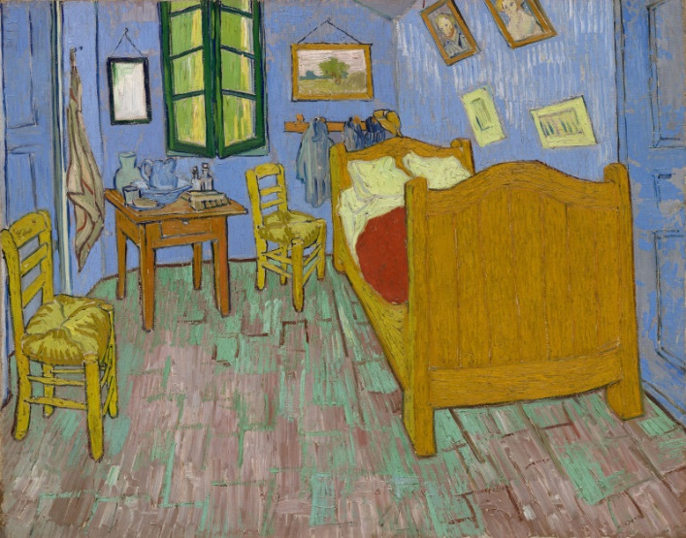.

<https://archive.artic.edu/van-gogh-bedrooms/about-paintings>

<https://www.vangoghmuseum.nl/en/collection/s0047V1962?v=1>

**\*The artist Vincent Van Gogh painted the Bedroom in 1888. He,as you right now, had spent quite a bit of time in this small bedroom which he rented in Arles, France. He was proud of this painting as it was very personal.**

*This week’s drawing involves you sitting in your room and drawing what is inside it. You can sketch each of the items separately or sit in the doorway and draw looking in. Beds, dressers, chairs, stuffed animals,& even pets!. Of course include all of your modern technological inventions that Van Gogh never had the pleasure of using!

**Use drawing paper, lined paper, or individual sticky notes!**

*Share your drawing with someone. Explain to them your assignment, how you completed it, even ask their opinion for a bit of advice. If you like what you did do another with a different outcome..