**NFCSD Art Educators**

**Grade 5**

***Still Life***

Supplies: pencils, crayons, colored pencils, and/or pen and paper, items from around your home (bowl of fruit, flowers in a vase, a teapot, a cup, etc.). Click on the website below to view many of Cezanne’s paintings and works of art.

<https://www.paul-cezanne.org/>

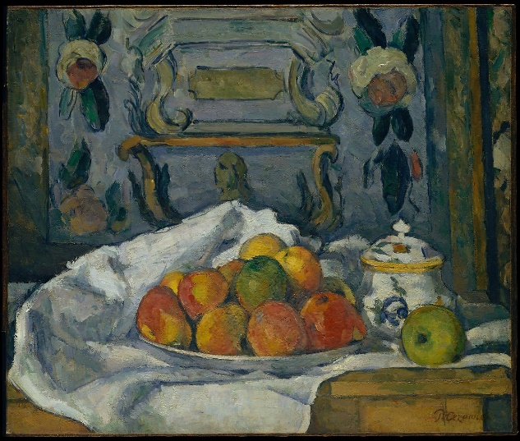

Many artists considered **Paul Cezanne** to be a genius. Cezanne painted simple shapes. His work was simple and flat. He used color to create form. He painted over 200 still life paintings. He used short brush strokes. At first, he painted in dark colors. Then, later, he added bright colors.

A **still life** is a work of art depicting mostly inanimate subject matter, typically commonplace objects which are either natural (food, flowers, dead animals, plants, rocks, shells, etc.) or man-made (drinking glasses, books, vases, jewelry, coins, pipes, etc.).

*Look around your home for some objects that would make an interesting picture. A bowl or plate of fruit, flowers, cups, anything that you find interesting. Gather 3-5 items and set them on a table or flat surface. You can arrange the items where they overlap each other. This will make it look more interesting. Draw the items using general shapes, keeping it simple. In your drawing, include the table, the walls behind the items, whatever else you see in your “still life”.

*You may use whatever you like to color your still life. Crayons, colored pencils or even paint, if you have it.

*When you are finished, share your drawing/painting with someone. Explain to them what you drew/painted and what a still life is. Tell them about Cezanne and what he painted.