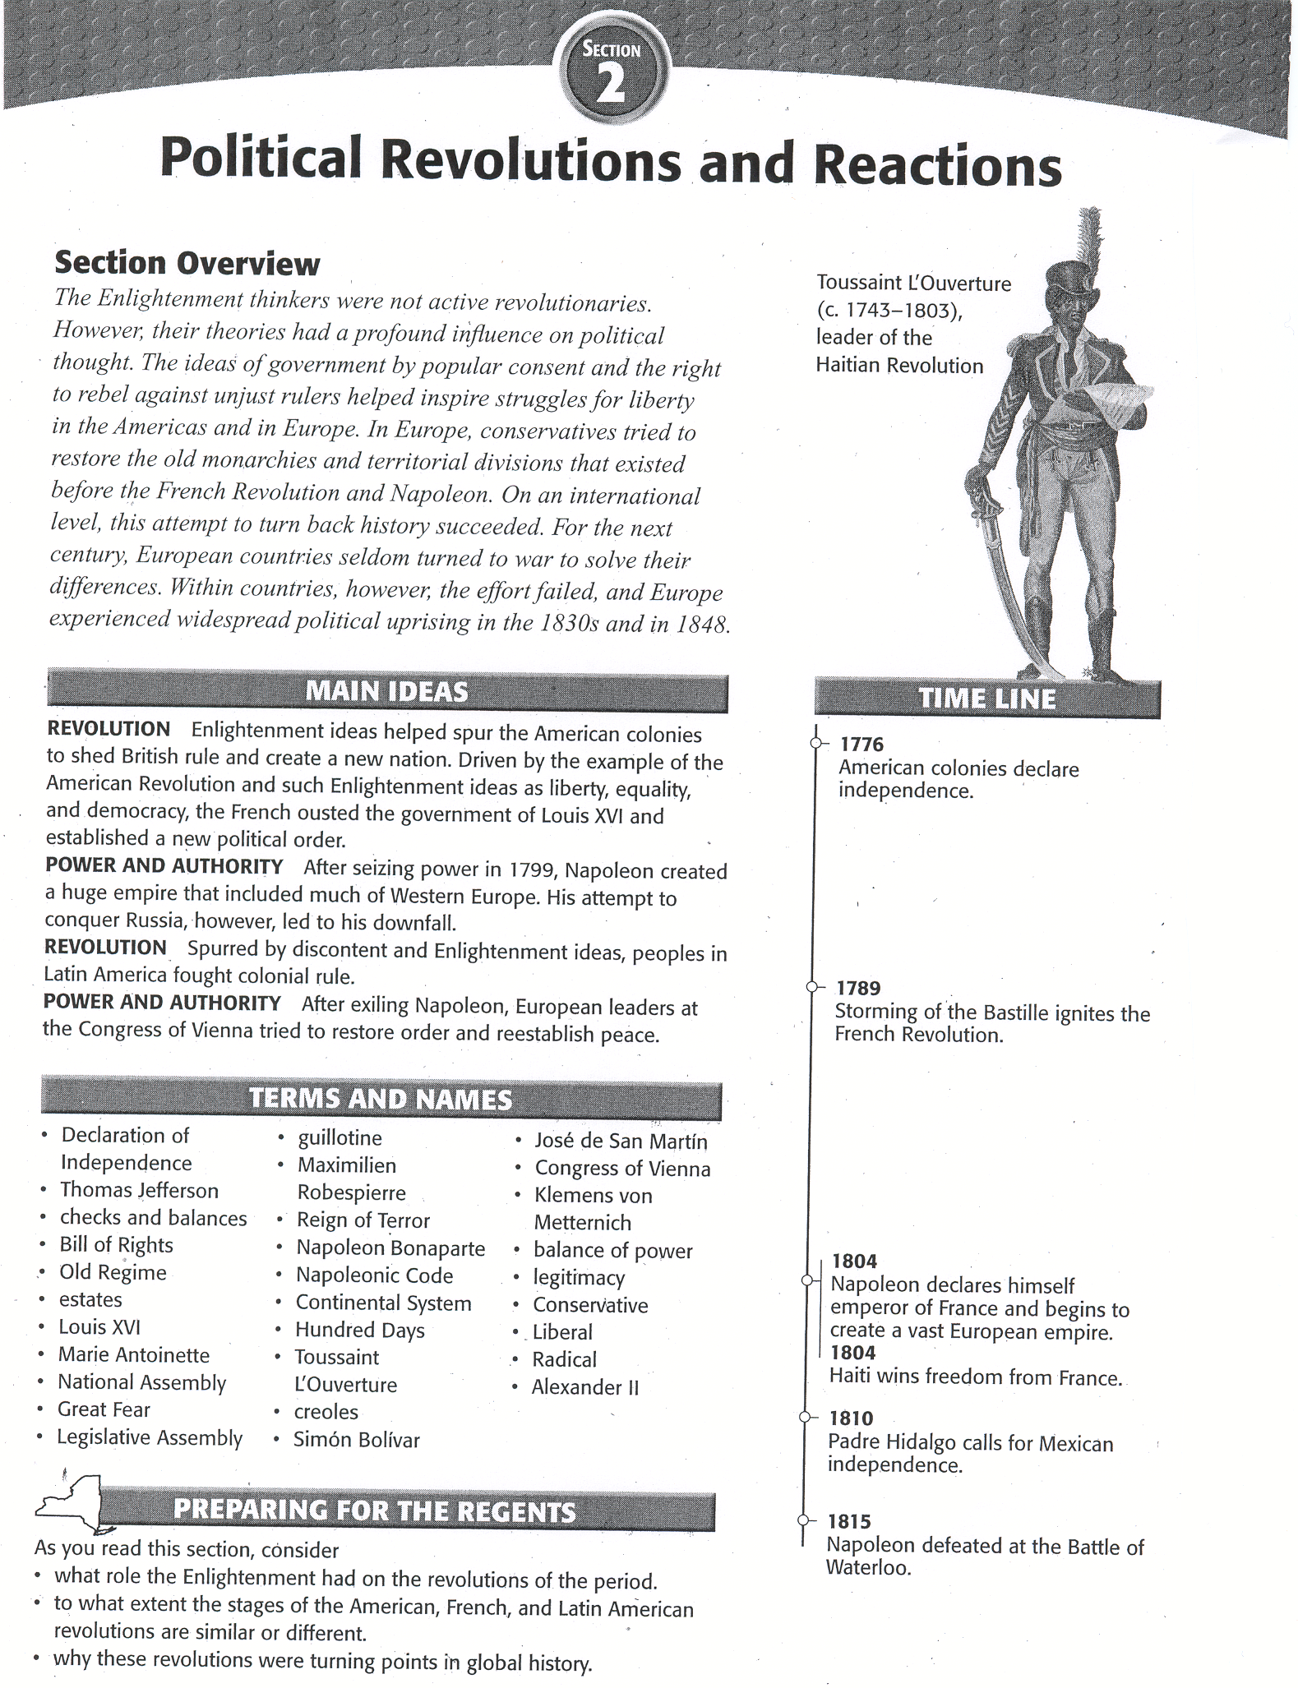

**Human and Physical Geography of Revolutions**

A revolution is a sudden or significant change in the old ways of doing things. Revolutions can occur in many areas, such as government, technology, art, and ideas. The Enlightenment is an example of a revolution in ideas. In the late 1700s and the 1800s, Enlightenment ideas about the proper role of government inspired people in the Americas and Europe to launch political revolutions that led to major governmental, social, and economic changes. In the Americas, people sought freedom from colonial rule. In Europe, first France and then other nations attempted to break free of the absolute control of monarchs. These rebellions changed the maps of Europe and the Americas and usher in a new age of politics and nationalism.

# The American Revolution

Between 1754 and 1763, the English and the French squared off in North America in the French and Indian War. Britain and its colonies were victorious, but the war left Great Britain with a huge debt. Because the American colonies benefited from the victory, Britain expected the colonists to help pay the costs of the war. Beginning in 1765, Parliament passed a series of tax acts that required the colonists to pay taxes directly to the British government - something they had never had to do before. Colonial lawyers argued that these taxes violated colonists' natural rights, and they accused the government of "taxation without representation." In Britain, citizens consented to taxes through their representatives in Parliament. The colonists, however, had no representation in Parliament. Thus, they argued they could not be taxed.

**Impact of the Enlightenment** Over the next decade, hostilities between the two sides increased. Some colonial leaders favored independence from Britain. These leaders used Enlightenment ideas to justify their calls for independence. The colonists had asked for the same political rights as people in Britain, they said, but the king had stubbornly refused. Therefore, the colonists were justified in rebelling against a tyrant who had broken the social contract.

In July 1776, the Americans issued the **Declaration of Independence.** This document, written by political leader **Thomas Jefferson,** was firmly based on the ideas of John Locke and the Enlightenment. Since Locke had asserted that people had the right to rebel against an unjust ruler, the Declaration of Independence included a long list of George III's abuses. The document ended by declaring the colonies' separation from Britain.

The British were not about to let their colonies leave without a fight. Shortly after the publication of the Declaration of Independence, the two sides went to war. At first glance, the colonists seemed destined to go down in quick defeat. In the end, however, the Americans won their war for independence.

**Americans Create a Republic** In 1781, all 13 states ratified the Articles of Confederation, which established the United States as a republic, a government in which citizens rule through elected representatives. The Articles deliberately created a weak national government that consisted only of a Congress. Congress could declare war, enter into treaties, and coin money. It had no power, however, to collect taxes or regulate trade. Passing new laws was difficult because laws needed the approval of 9 of the 13 states.

Colonial leaders eventually recognized the need for a strong national government. In February 1787, Congress approved a Constitutional Convention to revise the Articles of Confederation. Using the political ideas of the Enlightenment, the delegates created a new federal system of government. Like Montesquieu, the delegates distrusted a powerful central government controlled by one person or group. They therefore established three separate branches - legislative, executive, and judicial. This setup provided a built-in system of **checks and balances**, with each branch checking the actions of the other two.

The delegates signed the new Constitution on September 17, 1787. In order to become law, however, the Constitution required approval by conventions in at least 9 of the 13 states. Supporters of the Constitution were called Federalists. Their opponents, the Anti-federalists, feared that the Constitution gave the central government too much power. They also wanted a bill of rights to protect the rights of individual citizens. The Federalists agreed, and the Constitution was ratified. Congress formally added the **Bill of Rights** as the first ten amendments to the Constitution. The amendments protected such basic rights as freedom of speech, press, assembly, and religion. Many of these rights had been advocated by Voltaire, Rousseau, and Locke.

**Impact of the American Revolution** The American Revolution inspired the growing number of French people who sought reform in their own country. They saw the new government of the United States as the fulfillment of Enlightenment ideals, and longed for such a government in France.

The Declaration of Independence was widely circulated and admired in France. In addition, the Constitution and the Bills of Rights marked a turning point in people's ideas about government. Both documents put Enlightenment ideas into practice. They expressed an optimistic view that reason and reform could prevail and that progress was inevitable. Such optimism swept across the Atlantic to France. Less than a decade after the American Revolution ended, an armed struggle to topple the government would begin in France.

#### The French Revolution

In the l700s, France was considered the most advanced country of Europe. It had a large population and a prosperous foreign trade. It was the center of the Enlightenment, and France's culture was widely praised and imitated by the rest of the world. However, the appearance of success was deceiving. There was great unrest in France, caused by bad harvests, high prices, high taxes, and disturbing questions raised by the Enlightenment ideas of Locke, Rousseau, and Voltaire.

**Causes of the Revolution** In the l770s, the social and political system of France- the **Old Regime** - remained in place. Under this system, the people of France were divided into three large social classes, or **estates.** Power rested in the hands of the First Estate - the Roman Catholic clergy - and the Second Estate-the nobility. The majority of people in these estates scorned Enlightenment ideas. The Third Estate included the bankers, factory owners, merchants, professionals, and skilled artisans who made up the bourgeoisie (BUR*zhwah*ZEE), or middle class; the tradespeople, apprentices, laborers, and domestic servants of the urban lower class; and peasant farmers. These people had no power to influence government. The Third Estate resented the First and Second Estates and embraced Enlightenment ideals. The heavily taxed and discontented Third Estate was ready for change. Serious economic problems also helped to generate a desire for change. By the 1780s, France's economy was in decline. This caused alarm, particularly among the Third Estate's bourgeoisie. The heavy burden of taxes made it almost impossible to conduct business profitably within France. 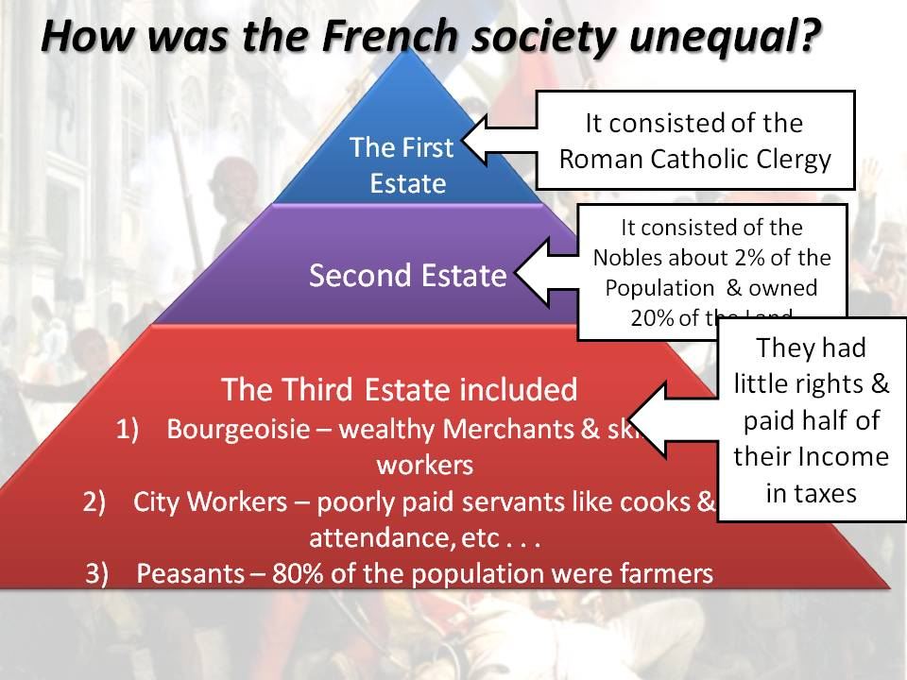 Further, the cost of living was rising sharply. In addition, bad weather in the 1780s caused widespread crop failures, resulting in a severe shortage of grain. The price of bread doubled in 1789, and many people faced starvation. To make matters worse, the government was deeply in debt, thanks in part to the extravagant spending of **Louis XVI** and his queen, **Marie Antoinette.** Louis also inherited a considerable debt from previous kings. And he borrowed heavily in order to help the American revolutionaries in their war against Great Britain, France's chief rival.

Strong leadership might have solved these and other problems. Louis XVI, however, was indecisive and allowed matters to drift until he was almost out of money. His solution was to impose taxes on the nobility; The Second Estate forced him to call a meeting of the Estates-General-an assembly of representatives from all three estates-to approve this new tax. The meeting, the first in 175 years, was held on May 5, 1789, at Versailles.

**Louis XVI and the Revolution** Under the assembly's medieval rules, each estate's delegates met in a separate hall to vote, and each estate had one vote. The two privileged estates could always outvote the Third Estate. Eager to make changes in the government, the Third Estate delegates insisted that all three estates meet together and that each delegate have a vote. This would give the advantage to the Third Estate, which had many more delegates.

Siding with the nobles, the king ordered the Estates-General to follow the medieval rules. This only made the Third Estate more determined. On June 17, 1789, the Third Estate delegates voted to establish the **National Assembly**, in effect proclaiming the end of absolute monarchy and the beginning of representative government. This vote was the first deliberate act of revolution. Three days later, the Third Estate delegates found themselves locked out of their meeting room. They broke down a door to an indoor tennis court, pledging to stay until they had drawn up a new constitution. Soon after, nobles and members of the clergy who favored reform joined the Third Estate delegates. In response to these events, Louis stationed his mercenary army of Swiss guards around Versailles.

In Paris, rumors flew. Some people suggested that Louis was intent on using military force to dismiss the National Assembly. Others charged that the foreign troops were coming to Paris to massacre French citizens. People began to gather weapons in order to defend the city against attack. On July 14, a mob searching for gunpowder and arms stormed the Bastille, a Paris prison, and seized the building. Before long, rebellion spread from Paris into the countryside. A wave of senseless panic called the **Great Fear** rolled through France.

The Old Regime died on August 4, 1789. On that day, motivated more by fear than idealism, noblemen joined with other members of the National Assembly to sweep away the feudal privileges of the First and Second Estates, thus making commoners equal to the nobles and the clergy. Three weeks later, the National Assembly adopted a statement of revolutionary ideals, the Declaration of the Rights of Man and of the Citizen. Reflecting the influence of the Declaration of Independence, the document stated that "men are born and remain free and equal in rights." These rights included "liberty, property, security, and resistance to oppression." The document also guaranteed citizens equal justice, freedom of speech, and freedom of religion.

In September 1791, the National Assembly completed France's new constitution, which Louis reluctantly approved. The constitution created a limited constitutional monarchy. It stripped the king of much of his authority. It also created a new legislative body - the **Legislative Assembly**. This body had the power to create laws and to approve or reject declarations of war. However, the king still held the executive power to enforce laws. The Legislative Assembly was split into three political factions. Radicals opposed the idea of a monarchy and wanted sweeping changes in the way the government was run. Moderates wanted some changes in government, but not as many as the radicals. Conservatives upheld the idea of a limited monarchy and wanted few changes in government.

Monarchs and nobles in many European countries watched the changes taking place in France with alarm. They feared that similar revolts might break out in their own countries. When Austria and Prussia urged the French to restore Louis to his position as an absolute monarch, the Legislative Assembly responded by declaring war in April 1792. The war began badly for the French. By the summer of 1792, Prussian forces were advancing on Paris. The Prussian commander threatened to destroy Paris if the revolutionaries harmed any member of the royal family. This enraged the Parisians. On August 10, about 20,000 men and women invaded the Tuileries, the palace where the royal family was staying. The mob massacred the royal guards and imprisoned Louis, Marie Antoinette, and their children.

Under pressure from radicals, the Legislative Assembly set aside the Constitution of 1791. It declared the king deposed, dissolved the assembly, and called for the election of a new legislature. This new governing body, the National Convention, took office on September 21. It quickly abolished the monarchy and declared France a republic. Adult male citizens were granted the right to vote and hold office. Despite the important part they had already played in the Revolution, women were not given the vote.

**Robespierre and the Reign of Terror** The National Convention had reduced Louis XVI's role from that of a king to that of a common citizen and prisoner. Now, guided by a radical political organization, the Jacobin (JAK*uh*bihn) Club, the Convention found Louis guilty of treason, and, by a very close vote, sentenced him to death. On January 21, 1793, the former king was beheaded by a machine called the **guillotine****.** His queen, Marie Antoinette, eventually met the same fate, as did thousands of others who the Jacobins considered enemies.

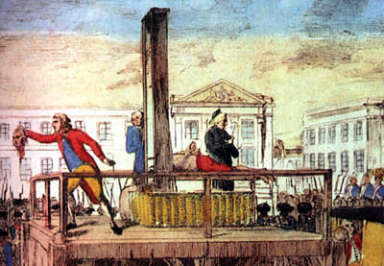In the early months of 1793, one Jacobin leader, **Maximilien Robespierre** (ROHBZ*peer), slowly gained power. Robespierre and his supporters set out to build a "republic of virtue" by wiping out every trace of France's past. In July 1793, Robespierre became leader of the Committee of Public Safety. For the next year, he governed France virtually as a dictator; and the period of his rule became known as the **Reign of Terror.** The Committee of Public Safety's chief task was to protect the Revolution from its enemies, including any radicals who challenged Robespierre's leadership. In 1793 and 1794, many of those who had led the Revolution received death sentences. In July 1794, fearing for their own safety, some members of the National Convention turned on Robespierre. They demanded his arrest and execution. The Reign of Terror, the radical phase of the French Revolution, ended on July 28, 1794, when Robespierre was beheaded.

People of all classes were weary of the Terror and of skyrocketing prices. In 1795, moderate leaders in the National Convention drafted a new plan of government, the third since 1789. It placed power firmly in the hands of the upper middle class and called for a two-house legislature and an executive body of five men, known as the Directory. These five were moderates, not revolutionary idealists. Some of them were corrupt and made themselves rich at the country's expense. Even so, they gave their troubled country a period of order. They also found the right general to command France's armies-Napoleon Bonaparte.

## The Rise and Fall of Napoleon

In October 1795, fate handed **Napoleon Bonaparte** a chance for glory. When royalist rebels marched on the National Convention a government official told Napoleon to defend the delegates. Napoleon and his gunners greeted the thousands of royalists with a cannonade. Within minutes, the attackers fled in panic. Napoleon Bonaparte became the hero of the hour.

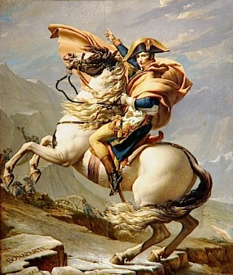

**Napoleon Seizes Power** By 1799, the Directory had lost control of the political situation and the confidence of the French people. In early November 1799, Napoleon moved to seize power. Troops under his command surrounded the national legislature and drove out most of its members. The lawmakers who remained voted to dissolve the Directory. In its place, they established a group of three consuls, one of whom was Napoleon. Napoleon quickly took the title of first consul and assumed the powers of a dictator.

Napoleon did not try to return the nation to the days of Louis XVI. In general, he supported laws that would both strengthen the central government and achieve some of the goals of the Revolution. He also took steps to put the economy back on a solid footing and end corruption and inefficiency in government. Napoleon thought that his greatest work was his comprehensive system of laws, known as the **Napoleonic Code.** This gave the country a uniform set of laws and eliminated many injustices. However, it actually limited liberty and promoted order and authority over individual rights. For example, freedom of speech and of the press, established during the Revolution, were restricted under the code. The code also restored slavery in the French colonies of the Caribbean.

**Napoleon Creates an Empire** In 1804, Napoleon decided to make himself emperor, and the French voters supported him. Not content simply to be master of France, Napoleon wanted to control the rest of Europe. He had already annexed the Austrian Netherlands and parts of Italy to France and set up a puppet government in Switzerland. Now he looked to expand his influence further. Fearful of his ambitions, the British persuaded Russia, Austria, and Sweden to join them against France. Napoleon met this challenge with his usual boldness. In a series of brilliant battles, he crushed the opposition. By 1812, the only areas of Europe free from Napoleon's control were Britain, Portugal, Sweden, and the Ottoman Empire.

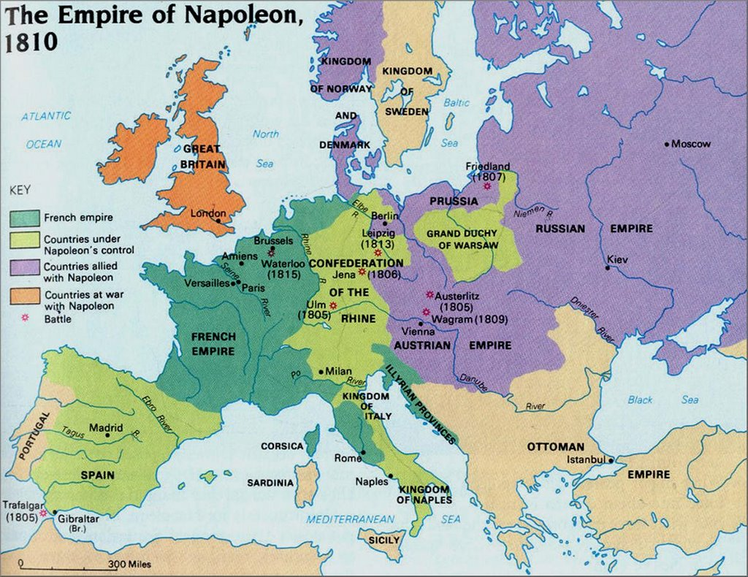

**Napoleon's Empire Collapses** The French Empire was huge but unstable. Napoleon was only able to maintain it at its greatest extent from 1807 to 1812. Then it quickly fell to pieces. Its sudden collapse was caused in part by Napoleon's actions. In his attempt to extend the French Empire and crush Great Britain, Napoleon made three disastrous mistakes. In 1806, he instituted the **Continental System,** which banned trade and communication between Europe and Great Britain. To enforce the system, Napoleon set up a blockade-a forcible closing of ports. The British responded with a much more effective blockade that prevented neutral ships from reaching European ports. Then, in 1808, in an attempt to force Portugal to accept the Continental System, Napoleon sent an invasion force through Spain. When Spain protested, he removed the Spanish king and put his own brother, Joseph, on the throne. This led to the Peninsular War, which cost Napoleon about 300,000 men. His most disastrous mistake of all came in 1812, when he invaded Russia. Out of a force of more than 420,000 soldiers, only about 10,000 survived the unsuccessful campaign.

Napoleon's enemies were quick to take advantage of his weakness. Soon all of the main powers of Europe were at war with France. Napoleon managed to raise another army. However, since most of his troops were untrained and ill prepared for battle, they were easily defeated. In April 1814, Napoleon accepted terms of surrender and gave up his throne. The victors gave Napoleon a small pension and exiled, or banished, him to Elba, a tiny island off the Italian coast. The allies expected no further trouble from Napoleon, but they were wrong.

Louis XVI's brother assumed the French throne as Louis XVIII. (The executed king's son, Louis XVII, had died in prison in 1795.) When word reached Napoleon that the new king was unpopular, he escaped from Elba and returned to France on March 1, 1815. Within days, Napoleon was again emperor of France.

In response, the European allies quickly marshaled their armies. The British army prepared for battle near the village of Waterloo in Belgium. On June 18, 1815, Napoleon attacked. The British army defended its ground all day. Late in the afternoon, the Prussian army arrived. Together, the British and the Prussian forces attacked the French. Two days later, Napoleon's exhausted troops gave way, and the British and Prussian forces chased them from the field. This defeat ended Napoleon's last bid for power, called the **Hundred Days.**

### Independence Movements in Latin America

Ideas of liberty, equality, and democratic rule found their way across the seas to Europe's colonies. In Latin America, most of the population resented the domination of European colonial powers. The time seemed right for the people who lived there to sweep away old colonial masters and gain control of the land.

**Revolution in Haiti** The French colony called Saint Domingue was the first Latin American territory to free itself from European rule. The colony, now known as Haiti, occupied the western third of the island of Hispaniola in the Caribbean Sea. The nearly 500,000 enslaved Africans worked on French plantations dramatically outnumbered their masters. In August 1791, 100,000 enslaved Africans rose in revolt. The formerly enslaved **Toussaint L'Ouverture** (too-SAN L00-vair-TOOR) soon emerged as a leader. By 1801, Toussaint had taken control of the entire island and freed all the enslaved Africans.

Toussaint was seized by French troops in May 1802 and sent to prison in the French Alps, where he died in April 1803. Toussaint's lieutenant, Jean-Jacques Dessalines (zhahn-ZHAHK day-sah-LEEN), took up the fight for freedom. On January 1, 1804, General Dessalines declared the colony an independent country. It was the first black colony to free itself from European control. Dessalines called the country Haiti.

**Revolutions in South America** Napoleon's conquest of Spain in 1808 triggered revolts in the Spanish colonies in the South American. These revolts were led by **creoles,** Spaniards born in Latin America. Many creoles might have supported a Spanish king. However, they felt no loyalty to a king imposed by the French. Recalling Locke's idea of the consent of, the governed, creoles argued that when the real king was removed, power shifted to the people. The South American wars of independence rested on the achievements of two brilliant creole generals -**Simon Bolivar** (see*MAWN boh*LEE*vahr), a wealthy Venezuelan, and **Jose de San Martin** (hoh*SAY day san mahr*TEEN), an Argentinean.

By 1821, Bolivar had won Venezuela's independence. San Martin's Argentina had declared its independence in 1816. However, Spanish forces in nearby Chile and Peru still posed a threat. In 1817, San Martin led an army on a grueling march across the Andes to Chile. He was joined there by forces led by Bernardo O'Higgins, son of a former viceroy of Peru. With O'Higgins's help, San Martin freed Chile.

In 1821, San Martin planned to drive the remaining Spanish forces out of Lima, Peru. But to do so, he needed a much larger force. To solve the problem, San Martin left his army for Bolivar to command. With unified revolutionary forces, Bolivar's army went on to defeat the Spanish at the Battle of Ayacucho (Peru) on December 9, 1824. In this last major battle of the war for independence, the Spanish colonies in Latin America won their freedom. The future countries of Venezuela, Colombia, Panama, and Ecuador were united into a country called Grand Colombia.

Brazil's quest for independence was unique in this period of Latin American history because it occurred without violent upheavals or widespread bloodshed. When Napoleon's armies invaded Portugal in 1807, Prince John (later King John VI) moved the Portuguese government to Portugal's largest colony, Brazil. After Napoleon's defeat, King John and the Portuguese government returned to Portugal. Dom Pedro, King John's son, remained in Brazil. King John intended to once again make Brazil a colony. However, many Brazilians could not accept a return to colonial status. In 1822, creoles demanded Brazil's independence from Portugal. Eight thousand Brazilians signed a petition asking Dom Pedro to rule. He agreed. On September 7, 1822, he officially declared Brazil's independence.

**Mexican Independence** In Mexico, Indians and mestizos, not creoles, played the leading role in revolt. First under, Padre Miguel Hidalgo (mee*GEHL ee*THAHL*goh) and then under Padre Jose Maria Morelos(moh*RAY*lohs), Indian and mestizo forces fought for independence. Both leaders were defeated by the Spanish army. Then, in 1820, events took a turn when a revolution in Spain put liberals in power there. Mexico's creoles, fearing the loss of their privileges in the Spanish-controlled colony, united in support of Mexico's independence. Ironically, Agustin de Iturbide (ah*goos*TEEN day ee*toor*BEE*day)-the man who had defeated the rebel Padre Morelo - proclaimed independence in 1821.

##### The Congress of Vienna

As revolutions shook the colonies in Latin America, Europe was also undergoing dramatic changes. After the French Revolution and the defeat of Napoleon, European heads of government wanted to establish long-lasting peace and stability on the continent. In 1814-1815, a series of meetings in Vienna, known as the **Congress of Vienna**, were called to setup policies to achieve this goal. Most of the decisions made in Vienna were made in secret among representatives of the five "Great Powers"-Russia, Prussia, Austria, Great Britain, and France. By far the most influential of these representatives was the foreign minister of Austria, **Prince Klemens von Metternich** (MEHT*uhr*nihk).

Metternich had three goals at the Congress of Vienna. First, he wanted to prevent future French aggression by surrounding France with strong countries. The Congress took the following steps to make the weak countries around France stronger: 1) The former Austrian Netherlands and Dutch Republic were united to form the Kingdom of the Netherlands. 2) A group of 39 German states were loosely joined as the newly created German Confederation, dominated by Austria. 3) Switzerland was recognized as an independent nation. 4) The Kingdom of Sardinia in Italy was strengthened by the addition of Genoa. Second, Metternich wanted to restore a **balance of power**, so that no country would be a threat to others. Third, he wanted to restore Europe's royal families to the thrones they had held before Napoleon's conquests, thereby affirming the principle of **legitimacy,** the hereditary right of a monarch to rule.

###### **Revolutions of the 1830s and 1848**

The French Revolution had given Europe its first experiment in democratic government. Although the experiment had failed, it set new political ideas in motion. Three schools of political thought struggled for supremacy in European society. **Conservatives** argued for protecting the traditional monarchies. **Liberals** wanted to give more power to elected parliaments, but only the educated and the landowners would vote. **Radicals** still held to the ideals of the French Revolution and favored drastic change to extend democracy to all people. Added to this was a growing nationalist movement that stressed that people's greatest loyalty should not be to a king or an empire but to a nation of people who share a common culture and history. This explosive mixture of ideas and factions would contribute directly to revolutions in the l830s and in 1848.

By the 1830s, the old order, carefully arranged at the Congress of Vienna was breaking down. Throughout Europe, liberals and nationalists were openly revolting against conservative governments. In October 1830, the Belgians declared their independence from Dutch rule. Conservatives were able to crush nationalist uprisings on the Italian peninsula and in Poland. By the mid-1830s, the old order seemed to have reestablished itself. But the appearance of stability did not last long. In 1848, ethnic uprising erupted throughout Europe. European politics continued to seesaw. Many liberal gains were lost to conservatives within a year. In one country after another, the revolutionaries failed to unite themselves or their nations. By l849, Europe had practically returned to the conservatism that had controlled governments before 1848.

##### Russian Absolutism

Russia also faced calls for reform in the 1800s. Unlike the rest of Europe, Russia still operated under a feudal system. Serfs were bound to the nobles whose land they worked. By the 1820s, many Russians believed that serfdom must end. In their eyes, the system was morally wrong. It also prevented the empire from advancing economically.

When the lack of industrial development led to Russia's defeat in the Crimean War, **Alexander II** decided to move the country toward modernization and social change. Alexander's first and boldest reform was freeing the serfs in 1861. The abolition of serfdom, however, went only halfway. Peasant communities - rather than individual peasants - received about half the farmland in the country. Each peasant community had 49 years to pay the government for the land. So, while the serfs were technically free, the debt still tied them to the land.

Reform ground to a halt when terrorists assassinated Alexander II in 1881. His successor, Alexander III, tightened czarist control over the country.