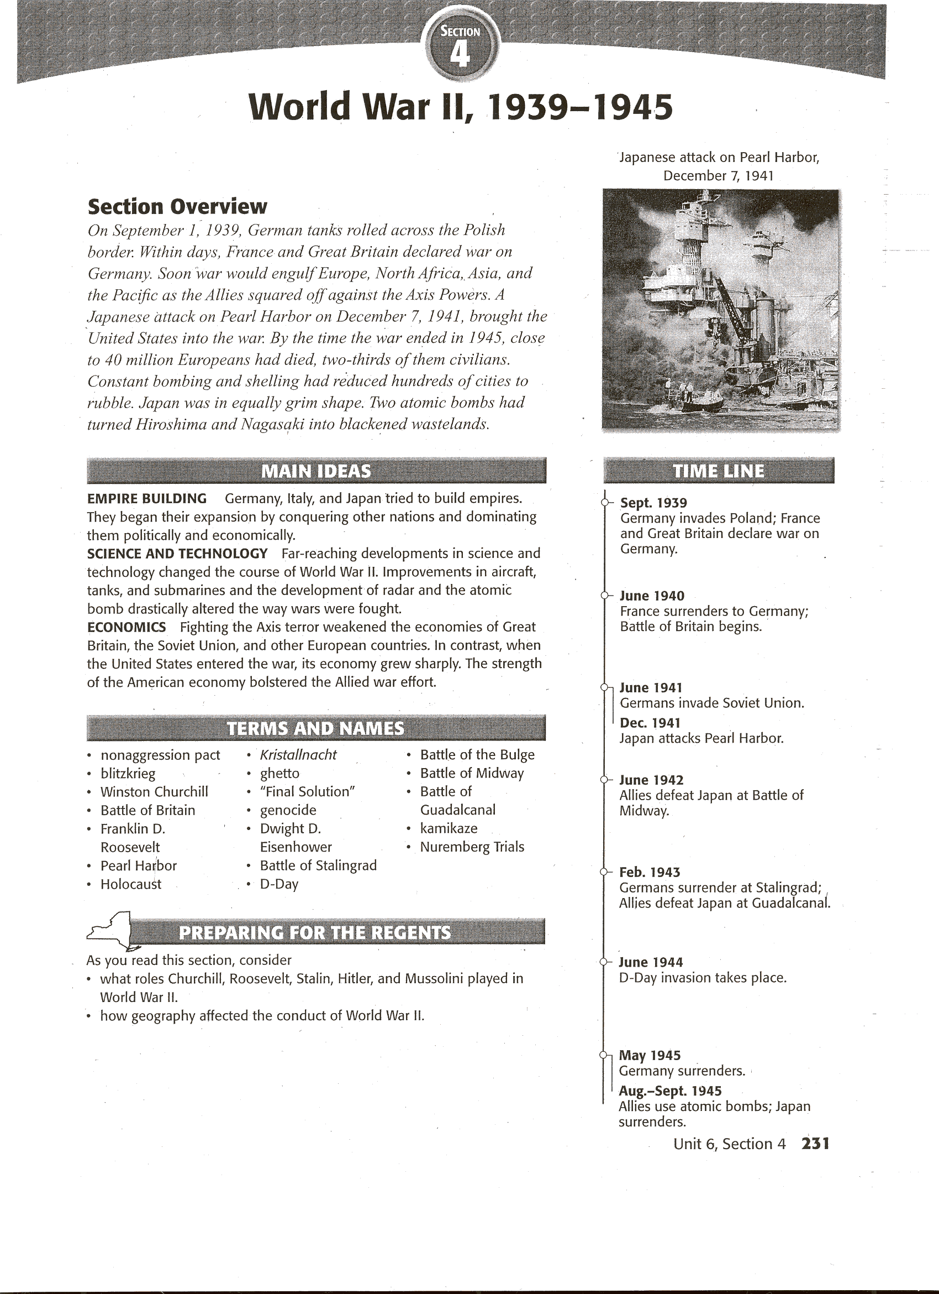

**Human and Physical Geography: The War Begins**

During the 1930s, Hitler played on the hopes and fears of the Western democracies. Each time he grabbed new territory, he would declare an end to his demands. Peace seemed guaranteed-until Hitler moved again. In 1939, Hitler demanded the return of the Polish Corridor, German territory that had been transferred to Poland following World War I. At this point, Soviet dictator Joseph Stalin signed a ten-year **non-aggression pact** with Hitler. In a secret part of the pact, Germany and the Soviet Union agreed to divide Poland between them. They also agreed that the USSR could take over Finland, Lithuania, Latvia, and Estonia.

After signing this non-aggression pact, Hitler quickly moved to conquer Poland. His surprise attack took place at dawn on September 1, 1939. German tanks and troop trucks rumbled across the Polish border. At the same time, German aircraft and artillery began a merciless bombing of Poland's capital, Warsaw. France and Great Britain declared war on Germany on September 3, but Poland fell some time before those nations could make any military response. After his victory, Hitler annexed the western half of Poland, which had a large German Population. The German invasion of Poland was the first test of Germany's newest military strategy-the **blitzkrieg** {BLIHTS-kreeg), or "lightning war."

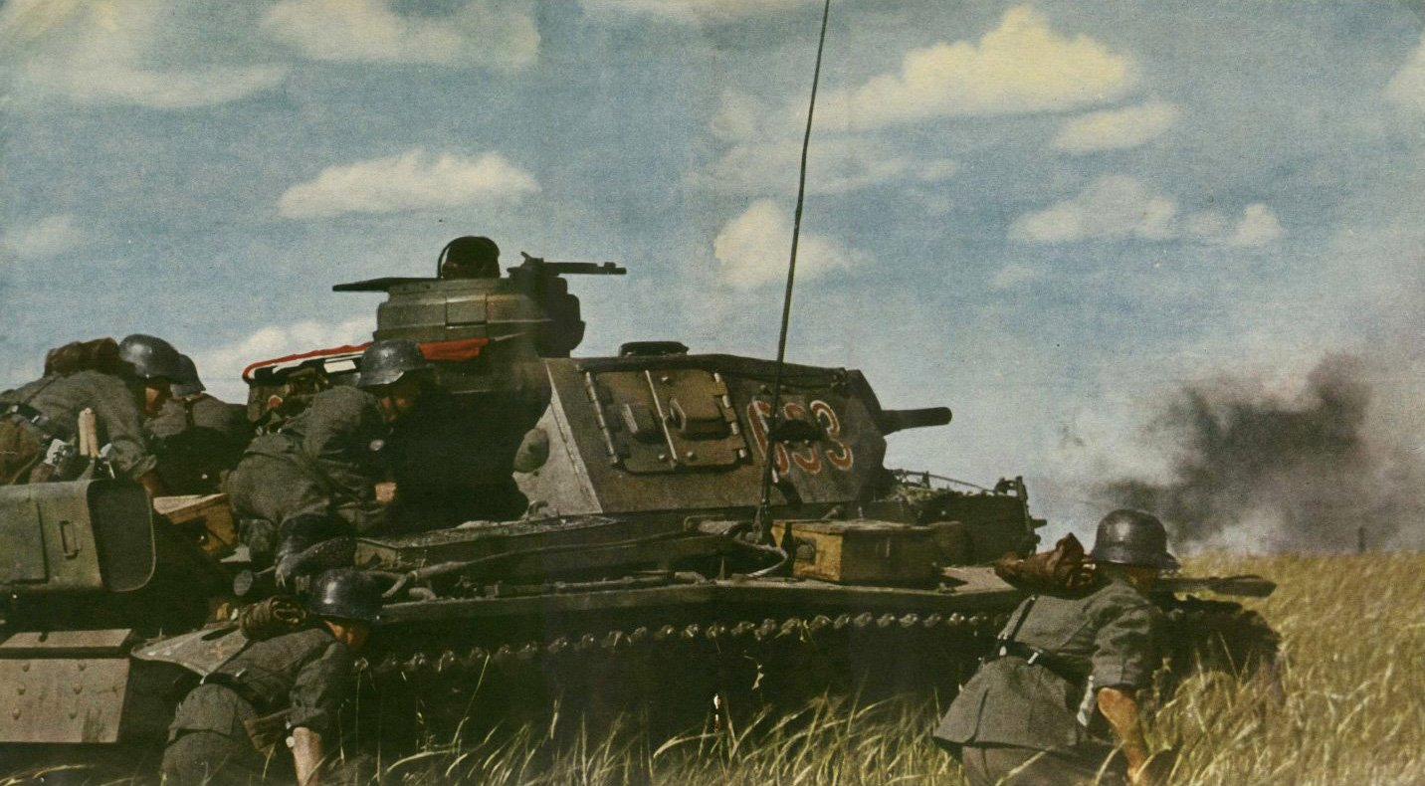

It involved using fast-moving airplanes and tanks, followed by massive infantry forces, to take enemy defenders by surprise and quickly over-whelm them. The case of Poland, the strategy worked.

On September 17, Stalin sent Soviet troops to occupy the eastern half of Poland. Stalin then moved to annex countries to the north of Poland. Lithuania, Latvia, and Estonia fell without a struggle, but Finland resisted. In November, Stalin sent nearly one million Soviet troops into Finland. The Soviets suffered heavy losses, but by March 1940, Stalin had forced the Finns to surrender.

# The Early War in Europe and the Mediterranean

After they declared war on Germany, the French and British mobilized their armies. They stationed their troops along the Maginot (MAZH-uh-NoH) Line, a system of fortifications along France's border with Germany.

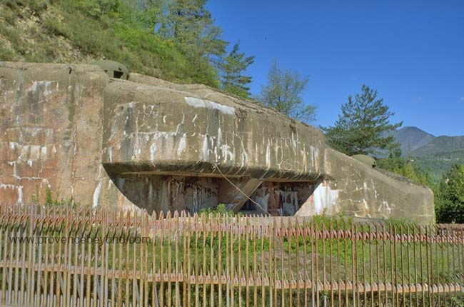

There they waited for the Germans to attack-but nothing happened. Suddenly, on April 9, 1940, Hitler launched a surprise invasion of Denmark and Norway. 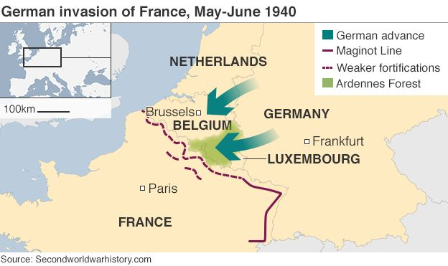In just four hours after the attack, Denmark fell. Two months later, Norway surrendered as well.

**Dunkirk and the Fall of France** In May 1940, Hitler began a dramatic sweep through the Netherlands, Belgium, and Luxembourg as part of his strategy to strike at France. Keeping the Allies’ attention on those countries, Hitler sent an even larger force toward France's northern coast. After reaching the French coast, the Germans swung north again and joined with German troops in Belgium. By the end of May 1940, the Germans had trapped the Allied forces around the northern French city of Lille (leel). The Allies retreated to the beaches of Dunkirk, a French port city near the Belgian border. In one of the most heroic acts of the war, Great Britain sent a fleet of about 850 military and civilian ships across the English Channel to Dunkirk to rescue the army. From May 26 to June 4, this amateur armada under heavy fire from German bombers, sailed back and forth from Britain to Dunkirk. The boats carried some 338,000 soldiers to safety.

Following Dunkirk, French resistance crumbled. By June 14, the Germans had taken Paris. French leaders surrendered on June 22, 1940. The Germans took control of the northern part of the country. They left the southern part to a French puppet government headquartered in the city of Vichy (VEESH-ee).

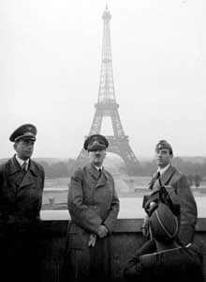 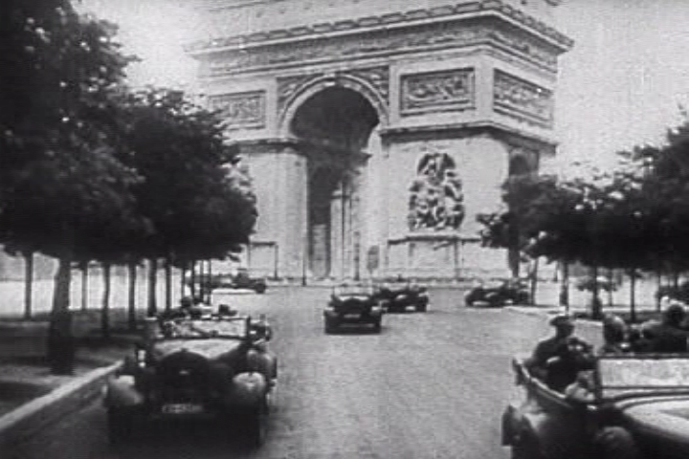

**The Battle of Britain** Hitler now turned to an invasion of Great Britain. In the summer of 1940, the Luftwaffe (LOOFT-VAHF-uh), Germany's air force, 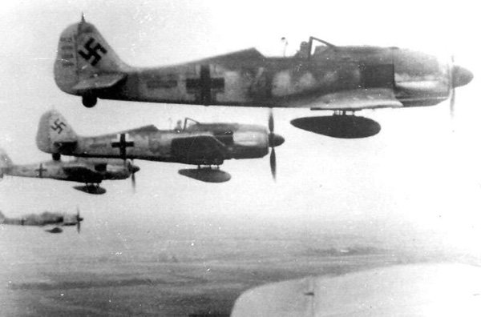 began bombing Britain's airfields, aircraft factories, and eventually its cities, especially London. True to the promise of **Winston Churchill,** Britain's prime minister, the British did not surrender.

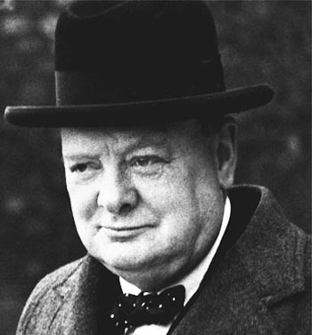

The Royal Air Force (RAF) began to hit back hard. Two technological devices helped turn the tide in the RAF's favor. One was an electronic tracking system known as radar. Developed in the late 1930s, radar could tell the number, speed, and direction of incoming warplanes. 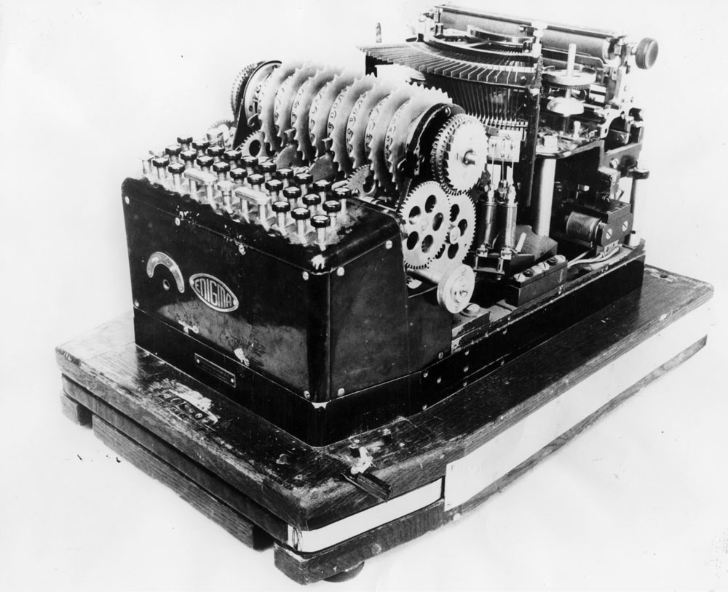

The other device was a German code-making machine named Enigma, which had been smuggled into Britain in the late 1930s. Enigma enabled the British to decode German secret messages and quick1y launch attacks on the enemy. To avoid the RAF's attacks, the Germans gave up daylight raids in October 1940 in favor of night bombing. The **Battle of Britain** continued until May 10, 1941. Stunned by British resistance, Hitler decided to call off his attacks.

**The Eastern Front** Hitler, instead, turned his attention to Eastern Europe. He quickly secured the Balkans in preparation for invading the Soviet Union. Early in the morning of June 22, 1941, the Germans launched the invasion. The Soviet Union was not prepared. The Germans pushed 500 miles inside the Soviet Union. As the Soviet troops retreated, they burned and destroyed everything in the enemy's path. The Russians had successfully used this scorched-earth strategy against Napoleon. On September 8, German forces put Leningrad under siege. By early November, the city was completely cut off from the rest of the Soviet Union. To force a surrender, Hitler was ready to starve the city's more than 2.5 million inhabitants. German bombs destroyed warehouses where food was stored. Nearly one million people died in Leningrad during the winter of 1941 -1942. Yet the city refused to fall.

Impatient with the progress in Leningrad, Hitler looked to Moscow, the capital and heart of the Soviet Union. A Nazi drive on the capital began on October 2, 1941. By December, the Germans had advanced to the outskirts of Moscow. The Soviets counterattacked. As temperatures fell, the Germans, in summer uniforms, retreated. Ignoring Napoleon's winter defeat 130 years before, Hitler ordered his generals to keep fighting. German troops dug in about 125 miles west of Moscow. They held on until March 1943. Hitler's advance on the Soviet Union gained nothing but cost the Germans 500,000 lives.

## The United States Aids Its Allies

Most Americans felt that the United States should not get involved in the war. But President **Franklin D. Roosevelt** knew that if the Allies fell, the United States would be drawn into the war.

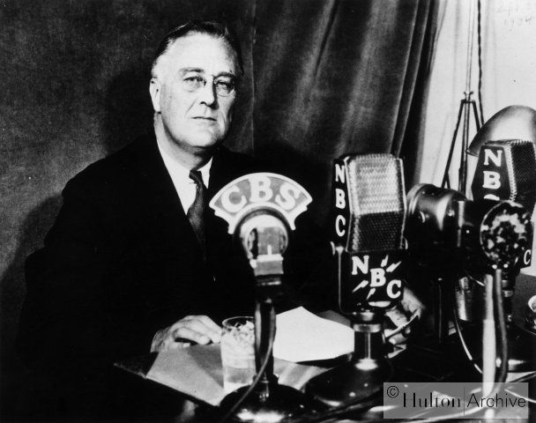

Under the Lend- Lease Act, passed in March 1941, the president could lend or lease arms and other supplies to any country vital to the United States. By the summer of 1941, the U.S. Navy was escorting British ships carrying U.S. arms. On September 4, a German U-boat fired on a U.S. destroyer in the Atlantic. In response, Roosevelt ordered navy commanders to shoot German submarines on sight. The United States was now involved in an undeclared naval war with Hitler.

# The War in the Pacific

To almost everyone's surprise the attack that actually drew the United States into the war did not come from Germany. It came from Japan. Ear1y in the morning of December 7, 1941, American sailors at **Pearl Harbor** in Hawaii awoke to the roar of explosives. 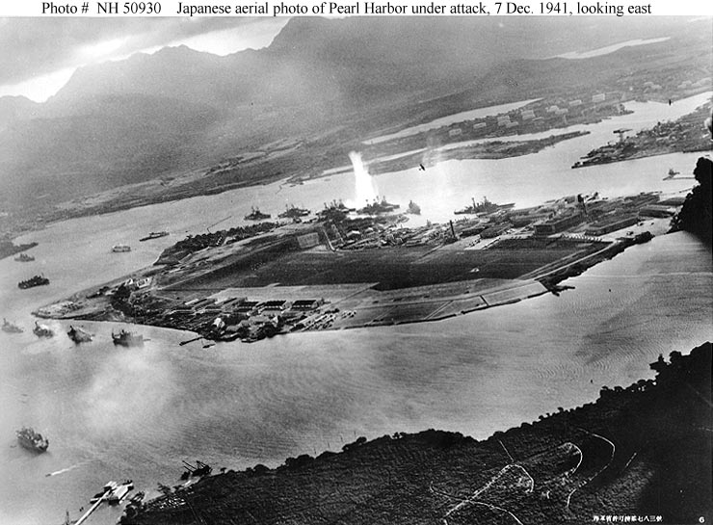A Japanese attack was underway U.S. military leaders had known that a Japanese attack might come, but not where. Within two hours, the Japanese had sunk or damaged 19 ships, including 8 battleships, moored in Pearl Harbor. More than 2,300 Americans were killed-with over 1,100 wounded. News of the attack stunned the American people. The next day, President Roosevelt addressed Congress. December 7, 1941, he declared, was "a date which will live in infamy." Congress quickly accepted his request for a declaration of war on Japan and its allies.

**Japanese Victories** The Japanese drive for a Pacific empire was under way. Lightly defended, Guam and Wake Island quickly fell to Japanese forces. The Japanese then turned their attention to the Philippines. In January 1942, they marched into the Philippine capital of Manila. American and Filipino forces took up a defensive position on the Bataan (buh-TAN) Peninsula on the northwestern edge of Manila Bay. The Japanese took the Bataan Peninsula in April.

The Japanese also continued their strikes against British possessions in Asia. After seizing Hong Kong, they invaded Malaya. By February 1942, the Japanese had reached Singapore, which surrendered after a fierce pounding. Within a month, the Japanese had conquered the resource-rich Dutch East Indies (now Indonesia), including the islands of Java, Sumatra, Borneo, and Celebes (SEHL-uh-BEEZ). The Japanese also moved westward, taking Burma.

By the time Burma fell, Japan had taken control of more than 1 million square miles of Asian land. They often treated the people of their new colonies with extreme cruelty. However, the Japanese reserved the most brutal treatment for Allied prisoners of war. The Japanese considered it dishonorable to surrender, and they had contempt for the prisoners of war in their charge. On the Bataan Death March-a forced march of more than 50 miles up the peninsula- the Japanese subjected their captives to terrible cruelties. Of the approximately 70,000 prisoners who started the Bataan Death March, only 54,000 survived.

**The Allies Strike Back** Slowly, the Allies began to turn the tide of war. Early in May 1942, an American fleet with Australian support intercepted a Japanese strike force headed for Port Moresby in New Guinea, the site of a critical Allied air base. Control of the air base would put the Japanese in easy striking distance of Australia. In the battle that followed, the Battle of the Coral Sea, both sides used a new kind of naval warfare. The opposing ships did not fire a single shot. Instead, airplanes taking off from huge aircraft carriers attacked the ships. The Allies suffered more losses in ships and troops than did the Japanese. However, the Battle of the Coral Sea was something of a victory, for the Allies had stopped Japan's southward advance.

# The Holocaust

As Japan worked to establish a new world order in Southeast Asia and the Pacific, the Nazis moved ahead with Hitler's design for a new world order in Europe. The racist message that Hitler had outlined in *Mein Kampf* eventually lead to the **Holocaust,**

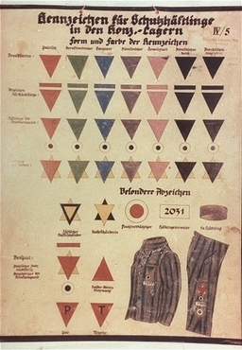

the systematic mass slaughter of Jews and other groups judged inferior by the Nazis. To gain support for his racist ideas, Hitler knowingly tapped into a hatred for Jews that had deep roots in European history. In Russia, for example, Alexander III had used pogroms (pul-GRAHMS)-organized campaigns of violence-against Jews. Nazis made the targeting of Jews a government policy. The Nuremberg Laws, passed in 1935, deprived Jews of their rights to German citizenship and forbade marriages between Jews and non- Jews. Laws passed later also limited the kinds of work that Jews could do.

Worse was yet to come. Early in November 1938, 17-year-old Herschel Grynszpan (GRIHN-shpahn), a German Jew, was visiting his uncle in Paris. Angered over news that his father was being deported to Poland, Grynszpan shot a German diplomat living in Paris. In response, Nazi leaders launched a violent attack on the Jewish community. On November 9, Nazi storm troopers attacked Jewish homes, businesses, and synagogues across Germany, murdering close to 100Jews and systematically smashing shop windows. The night became known **as *Kristallnacht*** (krih-STAHL-NAHKT), or "Night of Broken Glass."

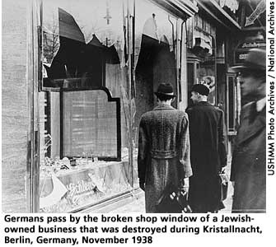

By the end of 1939, a number of German Jews had fled to other countries. Many, however, remained in Germany. Later, Hitler conquered territories in which millions more Jews lived. At first, Hitler favored emigration as a solution to what he called "the Jewish problem." Getting other countries to continue admitting Germany's Jews became an issue, however. Hitler developed a new plan. He ordered Jews in all countries under his control to be moved to designated cities, where theywere herded into dismal, overcrowded **ghettos,** or segregated Jewish areas.

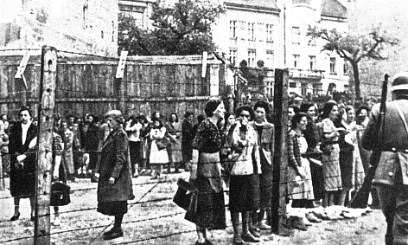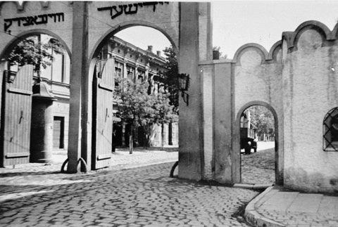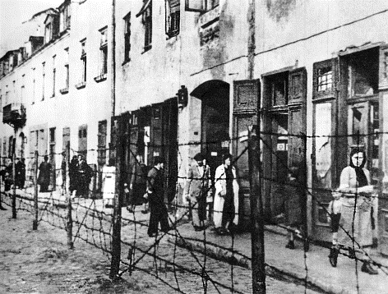

The Nazis then sealed off the ghettos with barbed wire and stonewalls. Theyhoped that the Jews inside would starve to death or die from disease. Even under these horrible conditions, the Jews hung on. Some formed resistance organizations within the ghettos. Theyalso struggled to keep their traditions.

Impatient waiting for Jews to die from starvation or disease, Hitler launched what he called the “Final Solution."

It was actually a program of genocide, the systematic killing of an entire people. Hitler believed that his plan of conquest depended on the purity of the German race. To protect racial purity, the Nazis had to eliminate other races, nationalities, or groups they viewed as "subhumans." They included Roma (gypsies), Poles, Russians, homosexuals, the insane, the disabled, and the incurably ill. But the Nazis focused especially on the Jews.

As Nazi troops swept across Eastern Europe and the Soviet Union, the killings began. Units from the SS (Hitler's elite security force) and their collaborators rounded up men, women, children, and even babies and took them to isolated spots. Theythen shot their prisoners in pits that became the prisoners' graves. 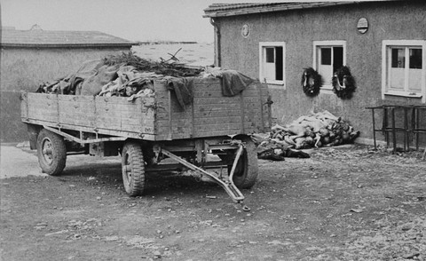

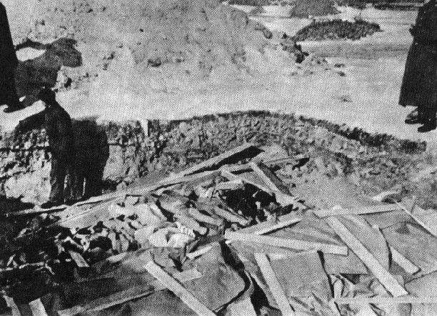Jews in communities not reached by the killing squads were rounded up and taken to concentration camps, or slave-labor prisons. These camps were located mainly in Germany and Poland.

The "Final Solution" reached its last stage in 1942. At that time, the Nazis built extermination camps equipped with huge gas chambers that could kill as many as 6,000human beings in a day. The largest of these camps was Auschwitz (OUSH-vihts). Some six million European Jews died in these death camps and in Nazi massacres. Fewer than four million survived. Some escaped the horrors of the death camps with help from non-Jewish people. 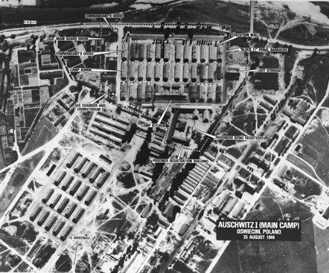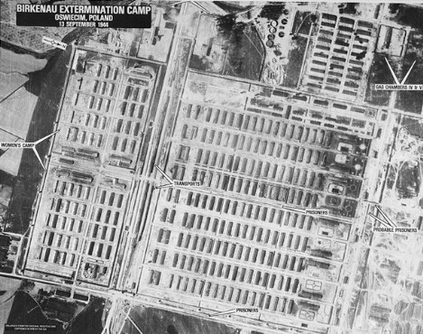

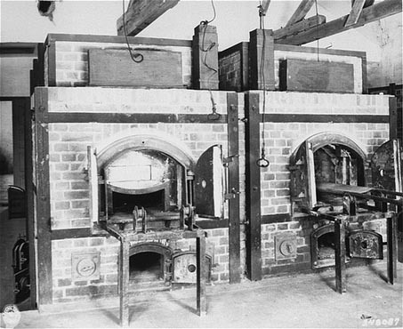

# The War Comes to an End

In December 22, 1941, just after Pearl Harbor, Winston Churchill and President Roosevelt met at the White House to develop a joint war policy. Stalin had asked his allies torelieve German pressure on his armies in the east. He wanted them to open a second front in the west. This would split the Germans' strength by forcing them to fight major battles in two regions instead of one. Churchill agreed with Stalin's strategy. The Allies would weaken Germany on two fronts before dealing a deathblow. Roosevelt ultimately agreed. Stalin wanted the second front to be in France, but Churchill wanted to strike first at North Africa and southern Europe.

**The Tide Turns** When German general Erwin Rommel took the key Libyan port city of Tobruk in June 1942, London sent General Bernard Montgomery- "Monty" to his troops-to take control of British forces in North Africa. By the time Montgomery arrived, however, the Germans had advanced to an Egyptian village called EI Alamein (AL*uh*MAYN), west of Alexandria. Montgomery decided his only option was a massive frontal attack. The Battle of EI Alamein began on the night of October 23. By November 4, Rommel's army had been beaten. He and his forces fell back. Then on November 8, an Allied force of more than 100,000 troops led by American general **Dwight D. Eisenhower** landed in Morocco and Algeria. Caught between Montgomery's and Eisenhower's armies, Rommel was finally crushed in May 1943.

German armies also met their match in the Soviet Union. The German advance had stalled at Leningrad and Moscow late in 1941. When the summer of 1942 arrived, Hitler sent his Sixth Army to seize the oil fields in the Caucasus Mountains and capture Stalingrad (now Volgograd), a major industrial center on the Volga River. The **Battle of Stalingrad** began on August 23, 1942. By early November 1942, Germans controlled 90 percent of the city. Then another Russian winter set in. On November 19, Soviet troops outside the city launched a counterattack. Closing in around Stalingrad, they trapped the Germans inside and cut off their supplies. Once again, Hitler would not let his army retreat. On February 2, 1943, some 90,000 frostbitten, half-starved German troops-all that remained of an army of 330,000-surrendered to the Soviets. Stalingrad's defense had cost the Soviets over one million soldiers. The city was 99 percent destroyed. However, the Germans were now on the defensive.

As the Battle of Stalingrad raged, Stalin continued to urge the British and Americans to invade France. However, Roosevelt and Churchill decided to attack Italy first. On July 10, 1943, Allied forces landed on Sicily and captured it from Italian and German troops about a month later. On July 25, King Victor Emmanuel III had Mussolini arrested. On September 3, Italy surrendered. But the Germans seized control of northern Italy and put Mussolini back in charge. Finally, the Germans retreated northward, and the victorious Allies entered Rome on June 4, 1944. Fighting in Italy, continued, however, until Germany fell in May 1945. On April 27, 1945, Italian resistance fighters ambushed some German trucks near the northern Italian city of Milan. Inside one of the trucks, they found Mussolini disguised as a German soldier. They shot him the next day and later hung his body in downtown Milan for all to see.

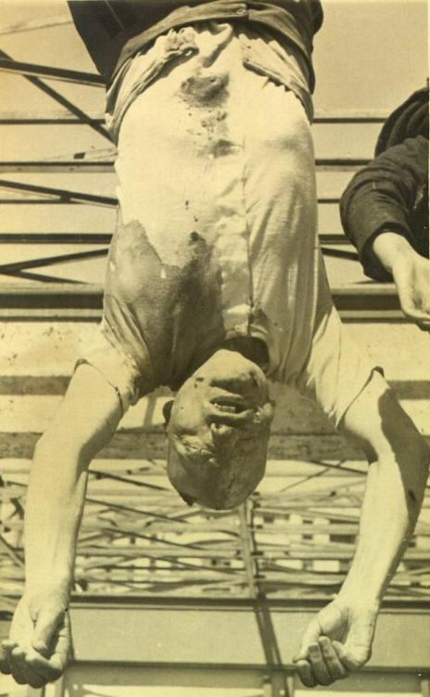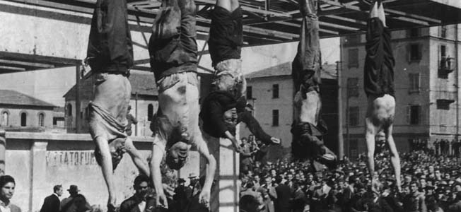

**Victory in Europe** In 1943, Stalin finally got his wish. The Allies began secretly building an invasion force in Great Britain. Their plan was to launch an attack on German-held France across the English Channel. By May 1944, the invasion force was ready. Thousands of planes, ships, tanks, and landing craft and more than three million troops awaited the order to attack. General Dwight D. Eisenhower, the commander of this enormous force, planned to strike on the coast of Normandy, in northwestern France. Code-named Operation Overlord, the invasion of Normandy was the largest land and sea attack in history. 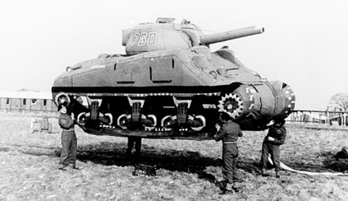

The invasion began on June 6, 1944-known as **D- Day**. At dawn on this day, British, American, French, and Canadian troops fought their way onto a 60-mile stretch of beach in Normandy. The Allies took heavy casualties. Among the American forces alone, more than 2,700 men died on the beaches that day.

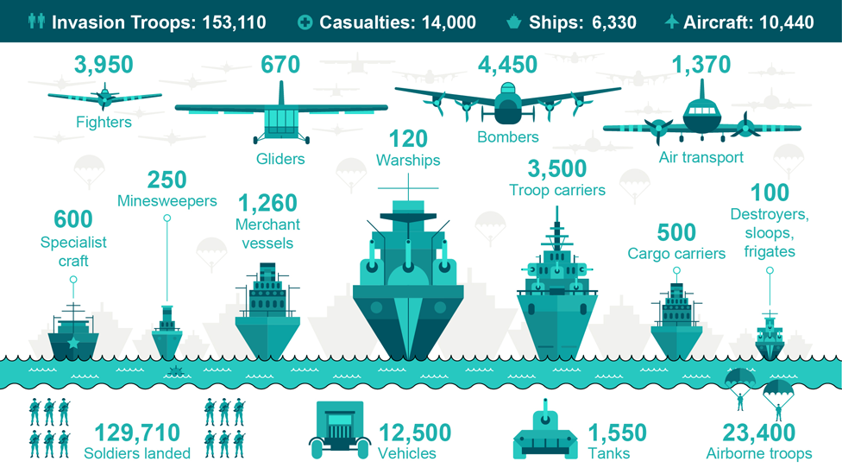

Despite heavy losses, the Allies held the beachheads. On July 25, the Allies punched a hole in the German defenses near Saint-Lo(san-LOH), and the United States Third Army, led by General George Patton, broke out. A month later, the Allies marched triumphantly into Paris. By September, they had liberated France, Belgium, and Luxembourg. They then set their sights on Germany.

As the Allied forces moved toward Germany from the west, the Soviet army was advancing toward Germany from the east. Hitler now faced a war on two fronts. In a desperate gamble, he decided to counterattack in the west. On December 16, German tanks broke through weak American defenses along a 75-mile front in northern France. The push into Allied lines gave the campaign its name-the **Battle of the Bulge.** Although caught off guard, the Allies eventually pushed the Germans back. The Germans had little choice but retreat, since there were no reinforcements available.

After the Battle of the Bulge, the war in Europe rapidly drew to a close. By the middle of April, a noose was closing around Berlin. Hitler prepared for his end in an underground headquarters beneath the crumbling city. On April 29, he married his longtime companion, Eva Braun. The next day, Hitler and Eva Braun committed suicide. Their bodies were then carried outside and burned.

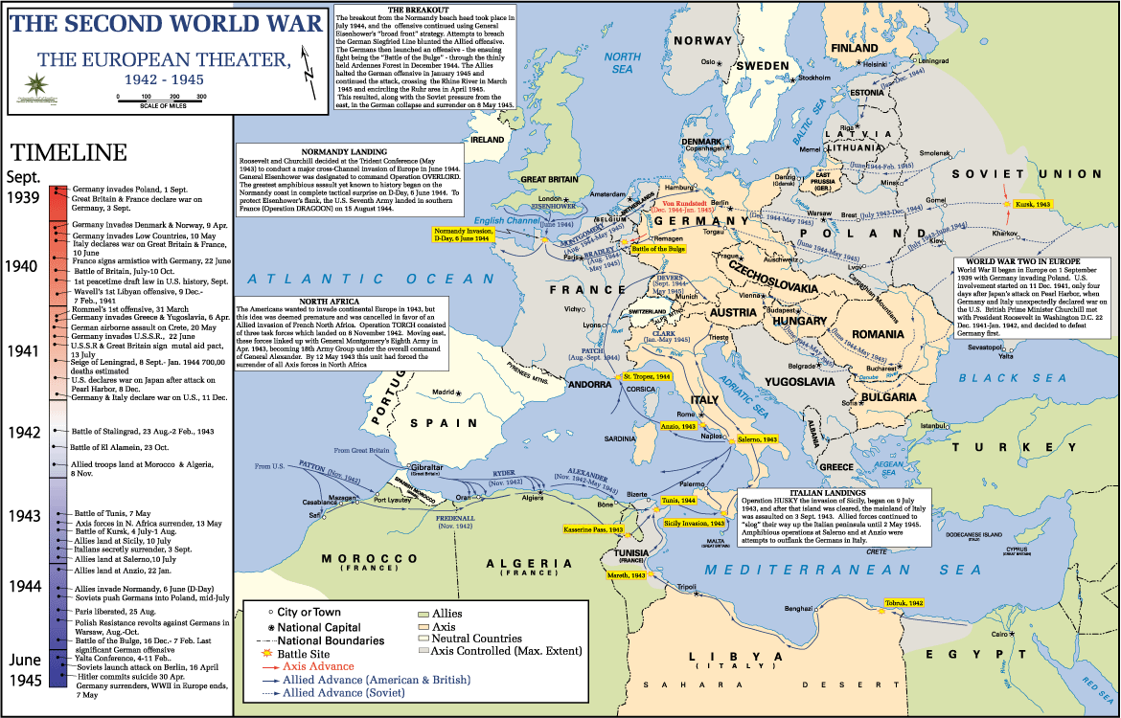On May 7, 1945, General Eisenhower accepted the unconditional surrender of the Third Reich from the German military. President Roosevelt, however, did not live to witness the long-awaited victory. He had died suddenly on April 12. Roosevelt's successor, Harry Truman, received the news of the Nazi surrender. On May 9, the surrender was, officially signed in Berlin. The United States and other Allied powers celebrated V-E Day-Victory in Europe Day.

**Victory in the Pacific** Although the war in Europe was over, the Allies were still fighting the Japanese in the Pacific. With the Allied victories in the **Battle of Midway** in June 1942 and the **Battle** **of Guadalcanal** in February 1943, however, the Japanese advances in the Pacific had been stopped. By the fall of 1944, the Allies were moving in on Japan. In October, Allied forces defeated the Japanese navy in the Battle of Leyte (LAY-tee) Gulf in the Philippines. Now, only the Japanese army and its feared kamikazes stood between the Allies and Japan. The **kamikazes** were Japanese suicide pilots.

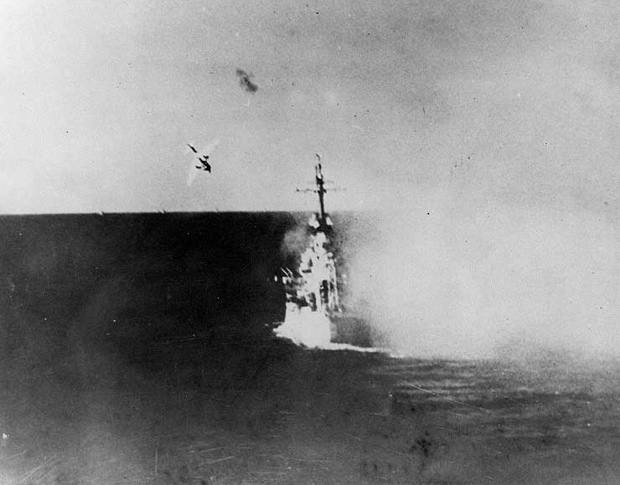

In March 1945, after a month of bitter fighting and heavy losses, American Marines took Iwo Jima (EE-wuh JEE~muh), an island 760 miles from Tokyo. On April 1, U.S. troops moved onto the island of Okinawa, only about 350 miles from southern Japan. The Japanese put up a desperate fight. Nevertheless, on June 21, one of the bloodiest land battles of the war ended. The Japanese lost over 100,000 troops, and the Americans 12,000.

After Okinawa, the next stop for the Allies had to be Japan. President Truman's advisers had informed him that an invasion of the Japanese homeland might cost the Allies half a million lives. Truman had to decide whether to use a powerful new weapon called the atomic bomb, or A-bomb. Most of his advisers felt that using it would bring the war to the quickest possible end.

President Truman then warned the Japanese that unless they surrendered, they could expect a "rain of ruin from the air." The Japanese did not reply. So, on August 6, the United States dropped an atomic bomb on Hiroshima, a Japanese city of nearly 350,000 people. Between 70,000 and 80,000 people died in the attack.

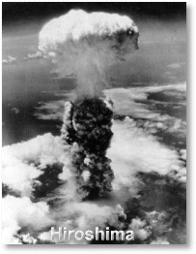

Three days later, on August 9, a second bomb was dropped on Nagasaki, a city of 270,000. More than 70,000 people were killed immediately. Radiation fallout from the two explosions killed many more. 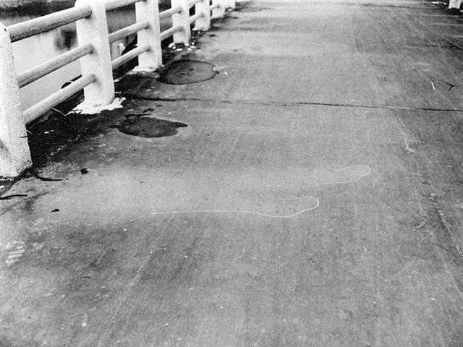

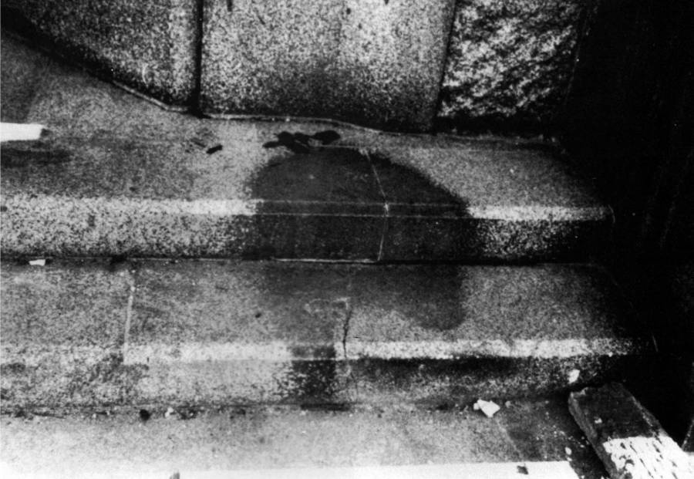The Japanese finally surrendered on September 2. The ceremony took place aboard the United States battleship *Missouri* in Tokyo Bay. With Japan's surrender, the war had ended. Now, countries faced the task of rebuilding a war-torn world.

# The War's Aftermath

After six long years of war, the Allies finally were victorious. However, their victory had been achieved at a very high price. World War II had caused more death and destruction than any other conflict in history. It left 60 million dead. About one-third of these deaths occurred in one country, the Soviet Union. Another 50 million people had been uprooted from their homes and wandered the countryside in search of somewhere to live. Property damage ran into billions of U.S. dollars.

While nations were struggling to recover, they also tried to deal with the issue of war crimes. During 1945 and 1946, an International Military Tribunal representing 23 nations put Nazi war criminals on trial in Nuremberg, Germany. In the first of these **Nuremberg Trials**, 22 Nazi leaders were charged with waging a war of aggression. They were also accused of committing "crimes against humanity"-the murder of 11 million people. Hitler and several of his top staff had committed suicide long before the trials began. However, Hermann Goring, the commander of the Luftwaffe; Rudolf Hess, Hitler's former deputy, and other high-ranking Nazi leaders remained to face the charges. Hess was found guilty and was sentenced to life in prison. Goring received a death sentence, but cheated the executioner by committing suicide. Ten other Nazi leaders were hanged on October 16, 1946. The bodies of those executed were burned at the concentration camp of Dachau (DAHK-ow). They were cremated in the same ovens that had burned so many of their victims.