**Screenshots of Student Views**

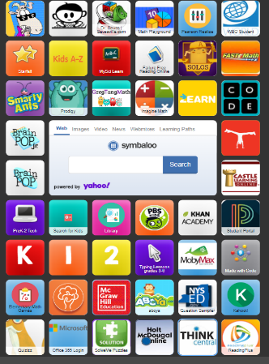

ThinkCentral App

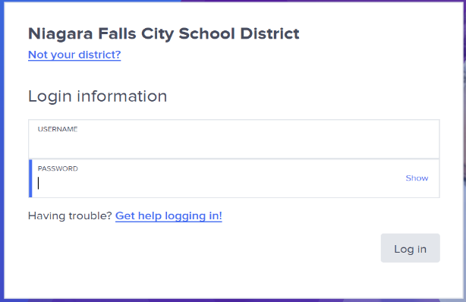

Student types their student number in both boxes

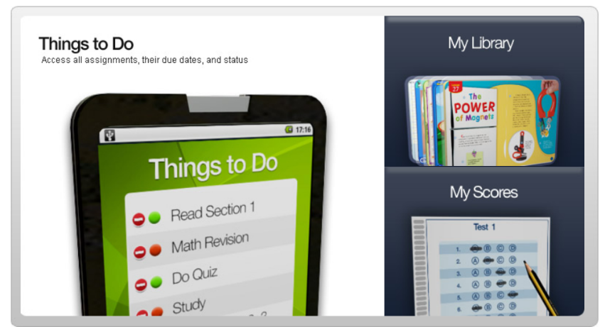

This is the student view. They can access materials through their Library.

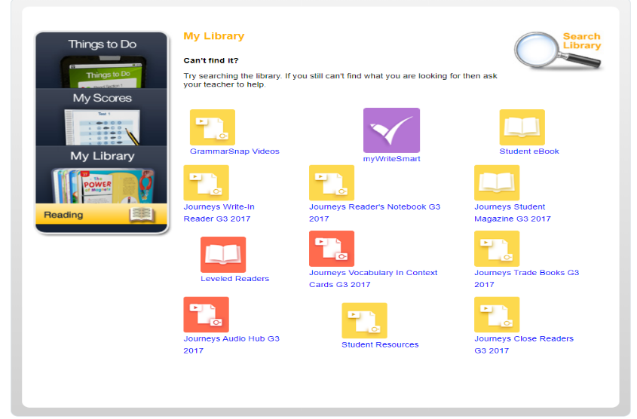

Student edition, Reader’s Notebook, grammar snap videos, leveled readers, etc.