**Step 1:**  Open your browser ex. Google Chrome or Edge

**Step 2:** Search for office.com

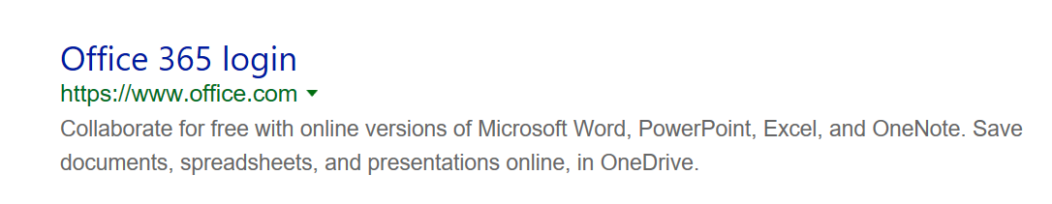

**Step 3:** Sign in with your computer [login@nfschools.net](mailto:login@nfschools.net) (ex. [Mjones@nfschools.net](mailto:Mjones@nfschools.net))

Password is your computer password.

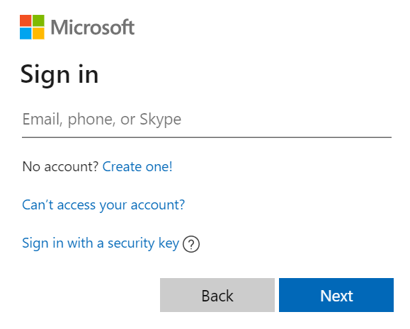

If your username or password does not work please reach out to: [mcacciatore@nfschools.net](mailto:mcacciatore@nfschools.net)

**Step 4:** Your screen should look like this

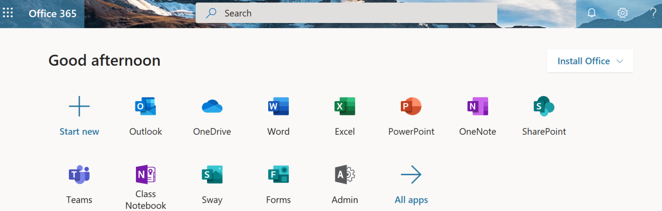

**Step 5:** Click on the **Teams App**. This will open your list of class Teams. Select a Team to view class Files and Assignments. **IF** the teacher adds an assignment please use the Turn In button to submit your work. 😊