Name_____________________________ Date: 12/16/16 Period____

Global 1: Fall of the Han Dynasty

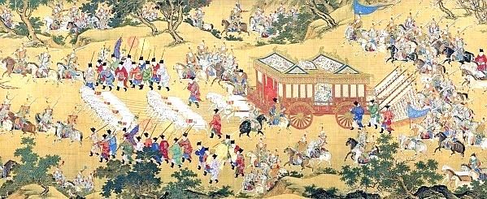 During the 1,000 years that the Roman Empire was conquering and ruling the Mediterranean Basin, other civilizations were developing in different parts of the world. One of the more powerful empires was the **Han Dynasty** which ruled the land of China for about 400 years. The Han Dynasty was famous for **normalizing** the many well-known things about ancient China like Confucianism, the Great Wall and the Civil Service system. However, just like Rome, the Han Dynasty did not last forever.

The emperors of the Han Dynasty were very powerful. They were able to control large areas of land for very long periods of time.

What did the Han emperor bring with him when he went for a ride? Why do you think he needed it/them?

____________________________________________________________________________________________

1. What was the Han Dynasty? Is it still around today?

______________________________________________________________________________________________________________________________________________________

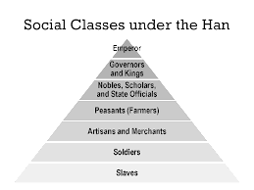The Han Dynasty was established in 220 BCE by the first emperor Han. Emperor Han forced the different **factions** of China into a united kingdom under his rule and began impressive reforms. Under the Han family, China built impressive roads, cities and aqueducts. The Han government was also highly organized into departments. This system of compartmentalization was called a **bureaucracy** (a system of government where a different department handles each responsibility) and it helped keep the central government strong.

Emperor Han organized his government around the social class hierarchy that existed at the time.

According to this image, which social class do you think had the best government jobs in the bureaucracy? Why?

____________________________________________________________________________________________________________________________________

1. How was the Han dynasty’s government different from the ones that came before it?

______________________________________________________________________________________________________________________________________________________

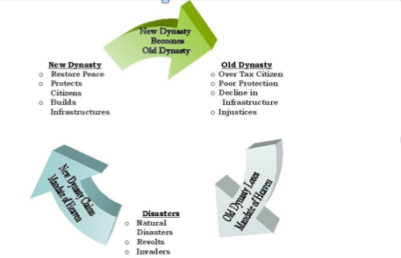 After ruling China fairly for 400 years, the Han Dynasty began to show signs of decay (rotting). The emperors who ruled later in the dynasty were corrupt and made poor decisions. They forced the lower classes to pay heavy taxes and gave them no rights. The emperors also refused to share power with the rich members of the upper class which upset them greatly.

The Han Dynasty was affected by the Dynastic Cycle just like every other dynasty that came before it. It ruled well for many years but did not last forever and was eventually replaced with a new dynasty.

According to this image, what happens to an Old Dynasty that allows new dynasties to claim the Mandate of Heaven?

_________________________________________________________________________________________________________________________________________________________________________________________________________________________________

1. What was wrong with the Han Dynasty’s government in the 220s AD?

______________________________________________________________________________________________________________________________________________________

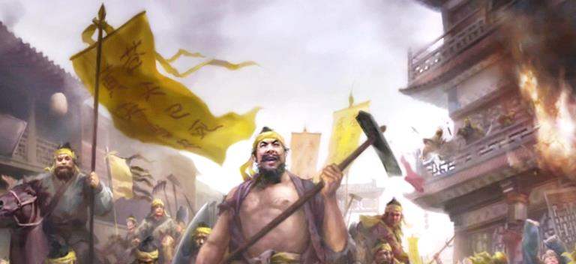In 200 AD, both the upper and lower classes united against the government in a series of **rebellions**. The peasants (poor, uneducated farmers) fought and killed government tax collectors and refused to work for the emperor anymore. The **Yellow Turban Rebellion** (named after the yellow cloth hats the peasants wore) greatly weakened the government.

The first rebellion against the Han government was the Yellow Turban Rebellion when the Chinese people revolted over high taxes.

How do you think the Han emperor felt about the rebellion? Why?

______________________________________________________________________________________

1. How did the peasants under the Han dynasty react to the corrupt government?

_________________________________________________________________________________________________________________________________________________________________________________________________________________________________

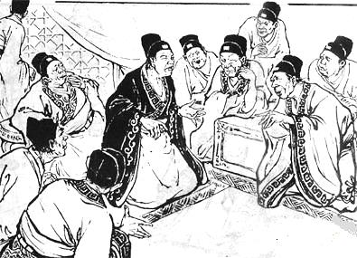With the emperor weak, rich upper class **nobles** began taking government jobs and responsibilities away from him by force. They started rumors about the emperor and claimed that he had lost the **Mandate of Heaven** (the right to rule by god) which prevented the government from doing its job properly. The rumors spread through the complex **mail** system the Chinese government had set up. The news spread far and wide and soon everyone in the entire country knew that the emperor was weak. These actions of **court intrigue** (officials acting unprofessional for personal gain)crippled the government at the exact time that it needed to be strong.

The Han government was greatly influenced by a group of people called the **eunuchs**. They spread rumors about the emperor and people believed them because of their powerful positions.

Do you think the eunuchs spreading rumors about the emperor was an act of betrayal? Why?

______________________________________________________________________________________________________________________________________________________

1. Why did the Han government start to weaken in the 200s?

______________________________________________________________________________________________________________________________________________________

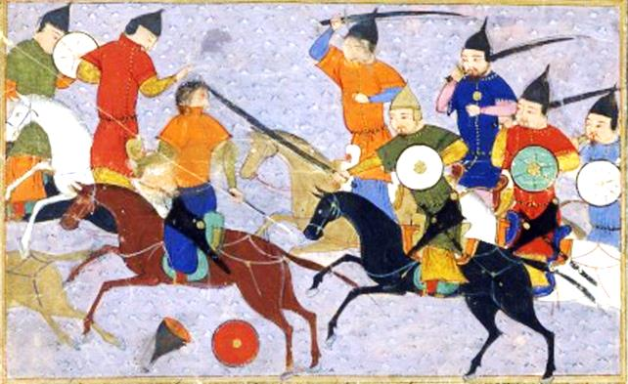In 220 AD a **nomadic** group of warriors from lands north of China began attacking remote areas of Han land. When no one stopped them, they pushed deeper into China and attacked roads and bridges and robbed unprotected Han citizens. The emperor was too weak to stop the Huns and the Han Dynasty began to collapse. Two years later in 222 AD, the Han emperor was **deposed** (removed from power against his will) and the Han Dynasty fell apart.

China was invaded by the Huns at a time when the government was too weak to stop them.

What do you think would have happened during the invasion if the Han Dynasty was as strong as it was in 220 BCE?

__________________________________________________________________________________________________________

1. What happened in 220 AD to the Han that also happened to the Roman Empire?

_________________________________________________________________________________________________________________________________________________________________________________________________________________________________

Name_____________________________ Date: 12/16/16 Period____

Global 1: Fall of the Han Dynasty Homework

1. Where was the Han Dynasty located?
2. Rome
3. China
4. Mesoamerica
5. Toledo
6. When was the Han Dynasty established?

_____________________

1. State 2 accomplishments of the early Han emperors

A.

__________________________________________________________________________________________________________________________________________________________________________________________________________________________________________

B.

__________________________________________________________________________________________________________________________________________________________________________________________________________________________________________

1. State two problems with the Han Dynasty that caused it to decline

A.

________________________________________________________________________________________________________________________________________________________________________________________________________________________________________________________________________________________________________________________

B.

________________________________________________________________________________________________________________________________________________________________________________________________________________________________________________________________________________________________________________________

1. What happened to China in 220 AD that finally forced the Han Dynasty to fall apart?
2. The British
3. The French
4. The Huns
5. The Vikings
6. Which civilization have you studied that had very similar accomplishments and problems as the Han Dynasty?

_______________________________________________________________________________________________________________________________________________________________________________________________________________________________________________________________________________________________________________________



**Rome**

**Han Dynasty**

**Han/Rome Comparison Chart**