Example 1: Morning Routine

|  |  |  |  |  |  |  |
| --- | --- | --- | --- | --- | --- | --- |
| Wake Up ex. 9:00am | Set a wake up time. This should stay the same. |  |  |  |  |  |
| Get Ready ex. 9:15am  15 minutes | This should include going to the bathroom, brushing hair and teeth and getting dressed. |  |  |  |  |  |
| Exercise ex. 9:30am  15 minutes | Visit Miss. Brick’s Webpage for Movement Breaks/Yoga links. |  |  |  |  |  |
| Breakfast  ex. 9:45am  15 minutes | Can get from local school. |  |  |  |  |  |
| School Work  ex. 10:45am  1 hour | Visit teacher’s Webpage for ideas. |  |  |  |  |  |
| Craft  ex. 11:45am  1 hour | Can include coloring, painting, drawing, playduh or a planned craft. Please visit Miss. Brick’s Webpage for crafts. |  |  |  |  |  |

Afternoon Routine

|  |  |  |  |  |  |  |
| --- | --- | --- | --- | --- | --- | --- |
| Lunch  ex. 12:15pm  30 minutes | Can get from local school. |  |  |  |  |  |
| Meditation  ex. 12:30pm  15 minutes | Go to Miss. Brick’s Webpage to complete daily activities.  Visit the Resource Guide on her Webpage for Meditation Apps. |  |  |  |  |  |
| Quiet Time  ex. 1pm  30 minutes | This can include a nap or read books. |  |  |  |  |  |
| School Work  Ex. 2pm  1 hour | Go to teacher’s Webpage for ideas. |  |  |  |  |  |
| Free Time  ex. 4pm  2 hours | This can include play time with toys or time in the backyard on a nice day. |  |  |  |  |  |

Evening Routine

|  |  |  |  |  |  |  |
| --- | --- | --- | --- | --- | --- | --- |
| Dinner  ex. 4:30pm  30 minutes | If you need food, visit the Resource Guide on Miss. Brick’s Webpage for food pantries. |  |  |  |  |  |
| Puzzles/Games  ex. 5:30pm  1 hour | This can include floor puzzles, board games, activity books with mazes, etc. |  |  |  |  |  |
| Family Movie  Ex 7pm  1.5 hours | Time with family doing an activity together. |  |  |  |  |  |
| Get Ready for Bed  ex. 7:30pm  30 minutes | This should include a bath, going to the bathroom, brushing teeth and getting on pjs. |  |  |  |  |  |
| Story Time  ex. 7:40pm  10 minutes | Have child pick a story for you to read them. |  |  |  |  |  |
| Goodnight  ex. 7:45pm | Set a bedtime. This should stay the same. |  |  |  |  |  |

Once task is complete you can put a sticker/star/smiley in the box. Set goals and rewards for stickers/star/smiley received. Start with small goals.

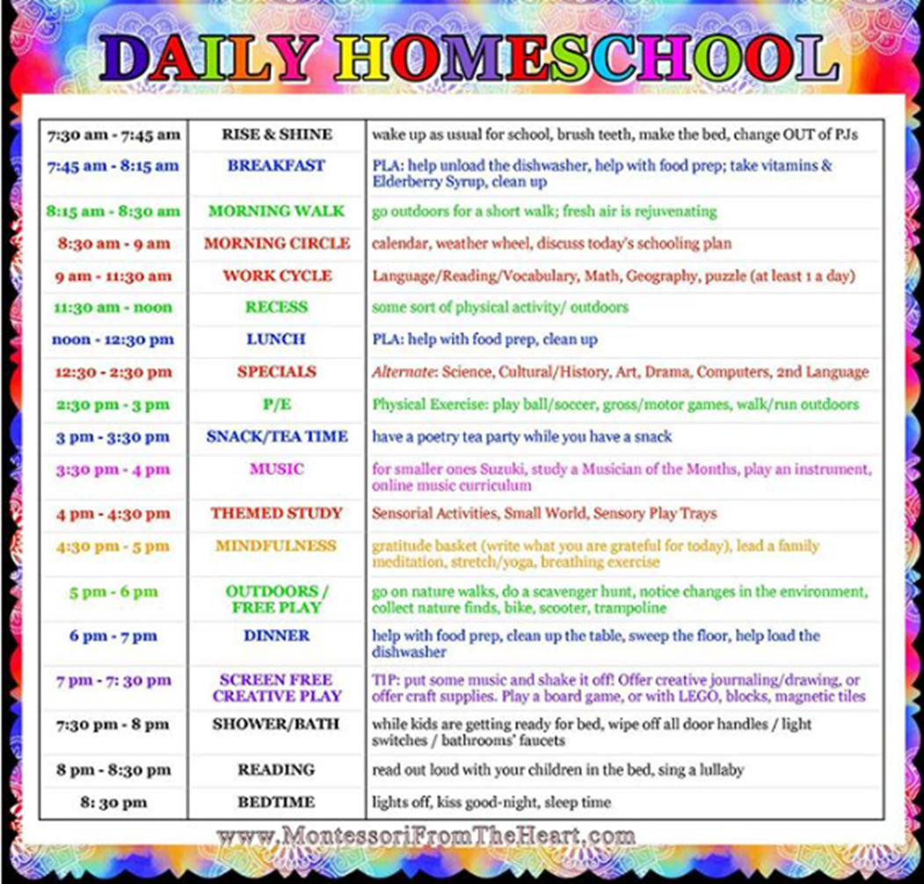Example 2: