Geography and History Activity
NORTH AND SOUTH
Lesson 2 People of the North
A Landscape for Industry
Several geographic factors helped the development of industry in New England beginning around 1800. The New England states had many rushing rivers and streams that could provide the waterpower needed to run factory machinery. Nearby, Pennsylvania’s coal, iron, and other natural resources needed for industry were easily within reach. Also, New England had several port cities. Through these ports, shipments of raw cotton from the South could be taken in, and finished cloth products could be sent out. Several industrial cities in New England sprang up to take advantage of these natural geographic features. The first planned industrial city in the United States was in Lowell, Massachusetts.
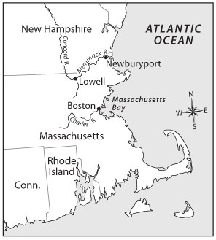
Natural Features
Investors looking for places to build textile mills were drawn to a site near where the Merrimack River joins with the Concord River. Here, at Pawtucket Falls, the Merrimack drops more than 30 feet in less than a mile. The falls create a nonstop flow of energy that could be used to power machinery. The city of Lowell was founded on this site in 1821.
Human Changes
The natural features of the site chosen for Lowell were outstanding. Yet, it was not long before mill owners began to change the landscape to make those natural features even more useful and available. Six miles of canals were built on two levels to bring waterpower to 40 mill sites in Lowell. Also, to make better use of the Merrimack River, mill owners dammed it. They held water in the dam overnight for the next day’s factory use. Lowell mill owners also bought water rights in New Hampshire. The owners stored the water in lakes in the spring and released it into the Merrimack during the dry seasons of summer and fall.

1. Understanding the Concept
Identifying What natural features most attracted investors to the Lowell site?
____________________________________________________________
____________________________________________________________
____________________________________________________________

2. Understanding the Concept
Analyzing Visuals What bodies of water were close to the Lowell mills?
____________________________________________________________

3. Understanding the Concept
Specifying What three changes did Lowell mill owners make to the landscape?
____________________________________________________________
____________________________________________________________
____________________________________________________________

4. Applying the Concept
Speculating How might the environment be affected by the changes that the Lowell mill owners made?
____________________________________________________________
____________________________________________________________

5. Applying the Concept
Drawing Conclusions How might raw materials needed for the manufacture of finished textile goods have been transported to Lowell?
____________________________________________________________
____________________________________________________________

