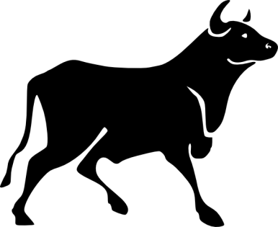

Name: __________________________________

Date: ______________

The Running of the Bulls

Directions: Read each article about The Running of the Bulls and answer the questions that follow.

**Part 1: Pamplona Bull Running**

The festival of San Fermin is more commonly known as the Running of the Bulls outside Spain. The festival officially begins at midday on 6th July every year with the ‘Chupinazo’ (opening ceremony) that takes place on the balcony of the Casa Consistorial in Pamplona. The ceremony is marked by a rocket being launched from the city hall and an explosion of fireworks. Thousands of people congregate in the square awaiting the mayor’s official announcement that the fiestas (parties) have begun, a rocket is launched, and the partying begins.

**History of the Running of the Bulls**

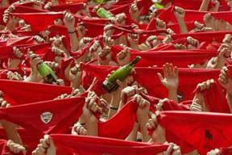The history of the bullrunning in Pamplona is not clear. There is evidence of the festival from as far back as the 13th century when it seems the events took place in October as this coincided with the festival of San Fermin on October 10th. It seems that the modern day celebration has evolved from this as well as individual commercial and bullfighting fiestas which can be traced back to the 14th century.

Over many years the mainly religious festival of San Fermin was diluted by music, dancing, bullfights and markets such that the Pamplona Council proposed that the whole event be moved to July 7th when the weather is far more conducive to such a celebration. To this day, San Fermin remains a fixed date every year with the first bullrun at 8am on July 7th and the last at the same time on July 14th.

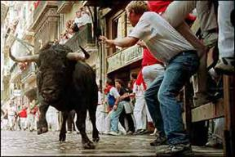The joining together of the religious, commercial and bullfighting festivals and the move to July 7th led to the first official celebration of San Fermines in 1591. The fiesta was a low key affair in comparison to the modern day festival, as it only lasted two days. Dancing and fireworks became features of the festival over the next few years and the event was extended to July 10th.

It was thanks to the writing of American writer Ernest Hemingway that San Fermin developed the notoriety of today. The publication of his novel “The Sun Also Rises” in 1926 told the world about the Pamplona bull running festival, which attracted people from all over the world to this annual festival.

**Part 1 Questions:**

1. The festival of San Fermin takes place in _________________________, Spain.
2. What is the opening ceremony called? ____________________________
3. What signals the beginning of the festival? ___________________________________________________________
4. What time and date does the festival begin? ___________________________________________________________
5. When it first began, the festival was mainly a _____________________ festival that grew to include music, dancing, and bullfights.
6. The festival gained notoriety when it was written about in __________________________’s novel, The Sun Also Rises.

**Part 2: The Bull Run – El Encierro**

The Pamplona bull run (el encierro) takes place at 8am every morning from 7th to 14th July. There are eight runs in total. Runners must be in the running area by 7.30am. The actual run stretches from the corral at Santo Domingo where the bulls are kept to the bullring where they will fight that same afternoon. The length of the run is 825 meters (.51 miles) and the average time of the run from start to finish is about three minutes. Each day six fighting bulls run the route as well as two herds of bullocks.

Runners (called *mozos*) dressed in white with a red handkerchief around their necks pray to San Fermin, then a second rocket announces that the bulls have left. The bulls and the runners then proceed along the route.

**[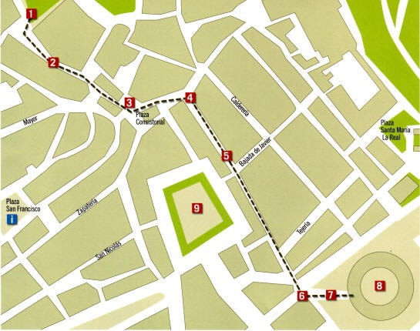](http://cdn.spanish-fiestas.com/wp-content/uploads/2012/05/pamplona-bull-run-map.jpg)**

**Bull Run Route**

1. Corralillos  
2. Cuesta de Santa Domingo  
3. Plaza del Ayuntamiento  
4. Curva de Mercaderes hacia Estafeta  
5. Calle Estafeta

6. Curva de Telefónica  
7. Callejón  
8. Plaza de Toros  
9. Plaza del Castillo

A third rocket is set off once all the bulls have entered the bullring and the fourth, and final, rocket means that the bulls are now in the bullpen and the bull run has finished. The vast number of people taking part in the bull run adds to the danger of running alongside wild bulls weighing in the region of 700kg (1500 lbs) each.

**A word of warning …** With the drinks flowing and the party in full swing you could be forgiven for forgetting that running the bulls is an extremely dangerous activity. Under no circumstances should you even consider running if you’re intoxicated. Not only are drunken people a risk to themselves, they are also a risk to everyone else. There are plenty security guards and first aid personnel, but there is little they can do during the running of the bulls such that 15 people have died and over 200 been seriously injured since 1924.

**Watching the Bullrunning**

You can stand behind the fences that mark the route of the bull run, but you need to arrive by around 6.30am to get the best spots on the top of the fence directly overlooking the run. Another good spot is in front of the museum on Santo Domingo where there isn’t a fence but the best spots here are usually taken before 6am leaving you with a cold two hour wait before the run starts. A great alternative is to **get yourself onto a balcony** overlooking the bullrun. You might be lucky enough to meet someone who invites you onto their terrace, alternatively, ask in the tourist information office. Your only other options are to go to the bullring and watch the end as the bulls arrive in the arena or to head for a bar and watch the bull run which is shown live every morning on national TV.

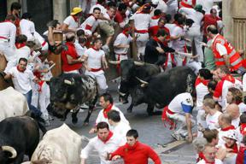**Watching the Bullfights**

On every evening of the fiesta beginning at 6.30pm on 7th July, there is a bullfight in the Pamplona bullring. Tickets for the bullfights are sold out well in advance as the arena only holds 12,500 people. Every evening after the day’s bullfight some tickets go on sale for the next evening’s event at the ‘taquillas’ at the bull ring. You’ll usually find ticket touts operating around the Plaza de Toros during the day and before the bullfight selling at elevated prices.

*Article and photography source: http://www.spanish-fiestas.com/festivals/san-fermin/*

**Part 2 Questions:**

1. Write the significance of each rocket signal:
   1. First rocket: ______________________________________________________
   2. Second rocket: ______________________________________________________
   3. Third rocket: ______________________________________________________
   4. Fourth rocket: ______________________________________________________
2. What is the length of the bull run? _______________________________
3. In Spanish, the bull run is called *el* ________________________________.
4. ___________ people have died and over ______________ have been seriously injured since 1924.
5. On the evening of every bull right, there is a _________________________.
6. Name three possible places to view the bull run: __________________________________________________________________________________________________________________________________________

**Article 3: Rules of the Bull Run**

* Runners should arrive at the start location before 7:30am. The rest of the run must be completely clear of runners until a few minutes before 8am.
* People under 18 years of age must not run or participate.
* Crossing police barriers placed is not permitted.
* Before the bulls are released, do not wait in corners, blind spots, doorways or in entrances to other establishments located along the run.
* Shop and apartment owners along the bull run must close their doors.
* You cannot be in the bull run while drunk, under the effects of drugs or in any other improper manner.
* You must wear appropriate clothes or footwear for the run.
* Do not run backwards towards the bulls.
* Holding, harassing or maltreating the bulls and stopping them from moving or being led to the pens in the bullring is not allowed.
* Do not stop along the run or block the path for other runners.
* Taking photographs inside the run is forbidden.

http://www.bullrunpamplona.com/

**Part 3:** Answer true or false:

1. Runners are allowed to run in any direction along the path, as long as they do not bump in to anyone.

True False

1. It is not allowed to take pictures inside the run.

True False

1. The race begins at 7:30 a.m.

True False

1. The bulls know the route by memory, and run freely.

True False

1. Only clothing that is appropriate for running is allowed.

True False

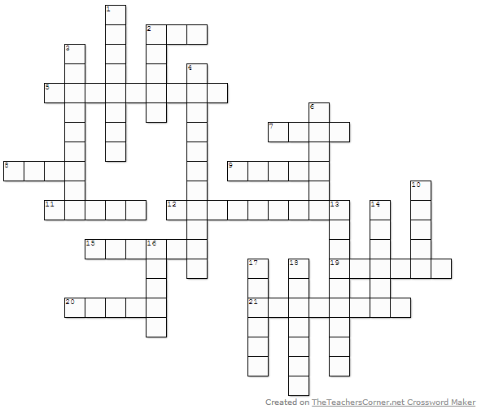**Crossword Puzzle:** Use the answers from the previous passages to fill in the crossword.

**Across**

**2.** Number of fighting bulls that run each day.

**5.** Each day ends in a ______________.

**7.** This festival takes place in the month of ___________.

**8.** Opening takes place in ________ Consistorial

**9.** The bull runners are called _____________.

**11.** The run ends in the Plaza de __________.

**12.** Do not run _____________ towards the bulls.

**15.** The ___________ rocket means that the run has finished.

**19.** Party in Spanish

**20.** Many bull runners wear red and ____________.

**21.** There are plenty of __________ guards on hand.

**Down**

**1.** the festival takes place in ___________, Spain. encierro: bull run in Spanish

**2.** country in which this festival takes place

**3.** opening ceremony

**4.** Taking ______________ inside the run is forbidden.

**6.** During the run, shop owners leave their doors ____________.

**10.** There are a total of _________ runs.

**13.** Bull run is actually called the festival of ___________.

**14.** ________ Hemingway made the bull run popular by writing about it.

**16.** 'The Sun Also ________' - name of book by Hemingway

**17.** A good spot to watch is at the __________ on Santo Domingo.

**18.** ______________ signal the beginning of the festival.