**Note to Student/Guardian:** We hope you will have fun creating our weekly art lessons. Feel free to **contact your art teacher** with any questions you may have about this lesson. When responding, please include : **Student Name, Grade, Classroom Teacher, Lesson Name.** We would be **happy** to hear from you!

Mr. Jocoy Mrs. Melloni **Mr. Johnson**

[ajocoy@nfschools.net](mailto:ajocoy@nfschools.net) [amelloni@nfschools.net](mailto:amelloni@nfschools.net) [majohnson@nfschools.net](mailto:majohnson@nfschools.net)

Ms. Ryan Mrs. Brooks

[tryan@nfschools.net](mailto:tryan@nfschools.net) [cbrooks@nfschools.net](mailto:cbrooks@nfschools.net)

**NFCSD Art Educators**

**4th Grade**

***Van Gogh Loved Books…***

***Materials: Favorite Book, Paper, pen, pencils,crayons, markers, clear tape***

**Vincent Van Gogh was a very famous artist that loved to paint objects, scenes, and the people in his world. There is a painting of his called THE YELLOW BOOKS.**

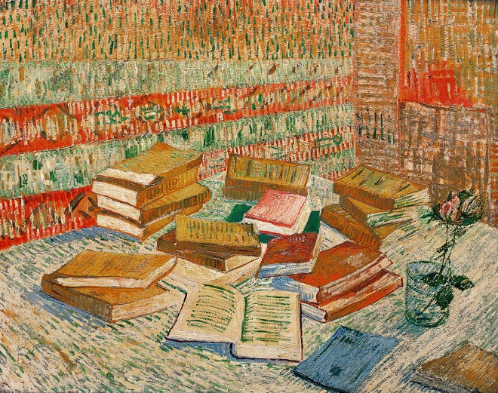

**He mentions his love of books in this slideshow by the Van Gogh Museum:** [VanGogh Slideshow](https://artsandculture.google.com/exhibit/which-books-did-vincent-van-gogh-read/kAKixNfo_Gy-IA?hl=en)

We can all agree that books can be amazing creations that take our minds off into distant places full of so many emotions.

***In this lesson you will be asked to find your favorite book(one with amazing cover art) and recreate the cover in your own style. You can try to redraw the exact same picture or a totally different one.***

***Please share your art side by side with the original and your version.***

***You can also ‘wrap’ your original book in your version to see how the new cover works and looks.***

***You may need an adult to help you with that part. Be careful with the tape***

***Have fun, be creative, stay safe and art it up!***