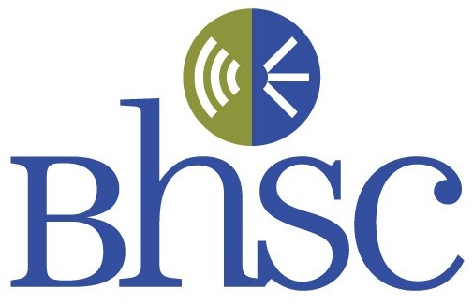
Buffalo Hearing & Speech Center
2011 Workshop Schedule – Revised
Continuing Clinical Competency (CCC) Series
Audiology/Speech-Language Pathology

Jan 12*** Title: Pediatric Feeding/Swallowing Disorders: Evaluation and Therapy
Speaker: Kristy Vogel, CCC-SLP, Buffalo Hearing & Speech Center

Feb 02 Title: Assessment of School Age Bilingual Children: How to work with an Interpreter
Speaker: Anny Castilla, Ph.D., CCC-SLP Fredonia State University – postponed until May 16, 2011

Mar 16 Title: Stuttering Therapy: Hands-on Practice with Stuttering Modification and Fluency Shaping Techniques
Speaker: Christopher Heximer, CCC-SLP, Buffalo State College (3 hour special- ends 7:45)

April 12** Title: The “Living with Hearing Loss” Program
Speaker: Samuel Trychin, Ph.D., Psychologist, Author

May 9***&**** Title: Special Education Law: What Teachers and Therapists Need to Know
(Monday) Speaker: Bruce Goldstein, Esquire, Goldstein, Ackerhalt, & Pletcher

May 10**&**** Title: Tomatis Listening Program
Speaker: Tama Crowell, CCC-SLP & Virginia Serpico, M.S., Baker Victory Services

May 16 Title: Assessment of School Age Bilingual Children: How to work with an Interpreter
(Monday) Speaker: Anny Castilla, Ph.D., CCC-SLP Fredonia State University

May 17 Title: Covert Stuttering Exposed: Personal Insights – Also, presentation on Buffalo Chapter of NSA
Speakers: Adrian McAdory & Bonnie Weiss, Buffalo Chapter, National Stuttering Assoc. (NSA)

Sept 21** Title: Auditory Processing Disorders Revisited – Beyond CAPD: Diagnosis and Pre/Post Therapy Results
Speaker: Kim Tillery, Ph.D., CCC-A, Fredonia State University

Sept 28***&**** Title: Response to Intervention: Special Educators and Therapists Working Effectively with Their Schools
Speaker: Theresa Janzcak, Ph.D., Buffalo State College

Oct 6***&**** Title: Introduction to the Brain Gym ® Program: Moving with Intention Leads to Optimal Learning
(Thursday) Speaker: Kate Baer-Gagola, M.S., Licensed Brain Gym Instructor/Consultant

Oct 11** Title: Newborn/Infant Hearing Screening, Evaluation, and Intervention
Speaker: Kenneth Deem, M.D., UB Medical School, Danielle Rocktaschel, CCC-A, Michelle Dube, CCC-A, & Lynn Shea, CCC-SLP, Buffalo Hearing & Speech Center

Oct 12***&**** Title: Behavior Management “Know How” for Special Educators & Therapists
Speaker: To Be Announced

Oct 18 Title: Incorporating Social Thinking into Social Communication/Pragmatics Therapy
Speaker: Nancy Hadyn-Hawkins, CCC-SLP, Clarence School District

Nov 02***&**** Title: Animal Assisted Interventions: Effects on Preschoolers with Disabilities
Speaker: Nancy Gee, Ph.D., Fredonia State University

Nov 09** Title: Tinnitus: Assessment and Intervention
Speakers: To be announced

\

** Audiology: Approved by AAA and ASHA for C.E. Credits
*** Joint OT/PT and SLP Workshop: Approved by AOTA, NYS (PT), and ASHA for C.E. Credits
**** Joint Special Education and SLP Workshop: Approved by ASHA for C.E. Credits

About the Series
The CCC series was developed by Buffalo Hearing & Speech Center in 2001 to assist Western New York Speech-Language Pathologists and Audiologists in meeting the requirements of the New York State Continuing Competency Law and ASHA certification requirements. The workshop series was expanded in 2009 to include sessions for Special Educators, Occupational Therapists (AOTA approved), and Physical Therapists (New York State Approved). Presentations emphasize hands-on, therapy-focused techniques. This series is presented by practicing clinicians for clinicians - low on lecture and high on practical applications. Please join us for our CCC workshops that are being offered at a central location, during convenient after-work hours, and at a reasonable cost.

Dates/Times/Place
Workshops are held on weekdays (M-Th) from 4:45 to 6:45 p.m. at Buffalo Hearing & Speech Center, 50 E. North Street Buffalo, NY, 14203. Parking is available in rear of building at no charge on a first come basis. Additional parking is available in the parking ramp directly across the street from Buffalo Hearing & Speech Center at a cost of $5.00.

Continuing Education Information- ASHA

Each course is offered for 0.2 ASHA CEUs (except March 16th which is 0.3 CEUs) (Intermediate level, Professional area).

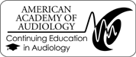
Continuing Education Information- AAA
Buffalo Hearing & Speech Center is approved by The American Academy of
Audiology to offer Academy CEUs. Each program is worth a maximum of .2 CEUs.
Academy approval of this continuing education activity does not imply endorsement of
course content, specific products, or clinical procedures.

Cost
The cost of each workshop is:
♦ $35 if payment is received seven days in advance
♦ $40 if payment is received less than seven days in advance
- All workshops may be purchased at a package price of $250. Payment can be made by credit card or check (payable to Buffalo Hearing and Speech Center). Fees paid are non-refundable.

Registration: By Phone or Mail
Please see page 3 for registration materials and information.

Registration: By Phone or Mail
To register by phone: Contact JoAnn DeMarco or Christine Zaciewski at Buffalo Hearing & Speech Center, 885-8318, (Credit Card Required)
- - - - - - - - - - - - - - - - - - - - - - - - - - - - - - - - - - - - - - - - - - - - - - - - - - - - - - - - - - - - - - - - - - - - - - -
To Register by Mail:
Please complete this form and mail with your registration fee to:
Buffalo Hearing & Speech Center
ATTN: JoAnn DeMarco, Buffalo Hearing & Speech Center, 50 E. North Street, Buffalo, NY 14203
Name: Organization:
Address: Daytime Phone: _______________
E-mail Address:
□ Package Price $250 (Attend all Workshops)
□ Package Audiology Price $100 (Attend all 5 Audiology Workshops)
□ List dates of workshops attending at $35 each
□ Total amount:
□ Amount Enclosed:  
□ Check (payable to Buffalo Hearing & Speech Center)
□ Credit Card Type: Credit Card#: ______________________________
Name on Card: _________ Expiration Date:___________________
Address:__________________________________________________________________________________

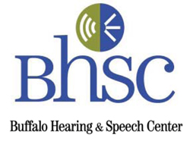
For More Information: visit our website at www.AskBHSC.org or call Joe Sonnenberg at 885-8871 ext. 210

